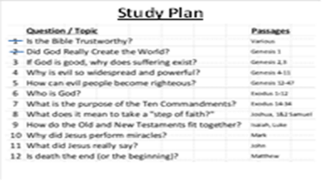
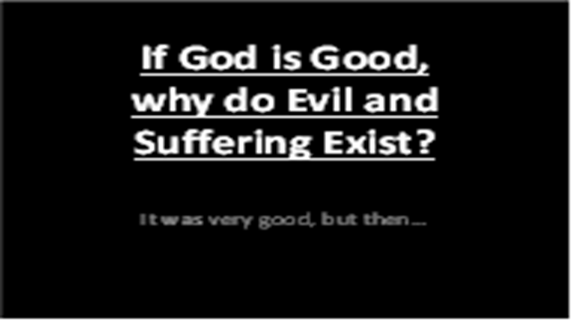
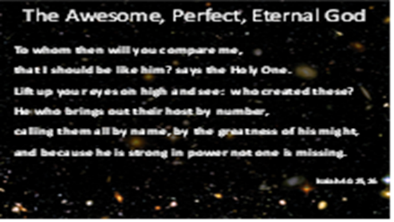 | As we begin, I want to remind you that every created thing had a beginning. As we back up into history, we eventually come to something that did not begin to exist – the only One who is eternally existing – the “first cause” of everything else. Of course, we are talking about the Awesome, Eternal God.  Read these verses from Isaiah 40:25,26 and remember who He is and who we are by contrast. He is the center of all attention, not us. When we get that reversed, we set ourselves up for confusion and despair.
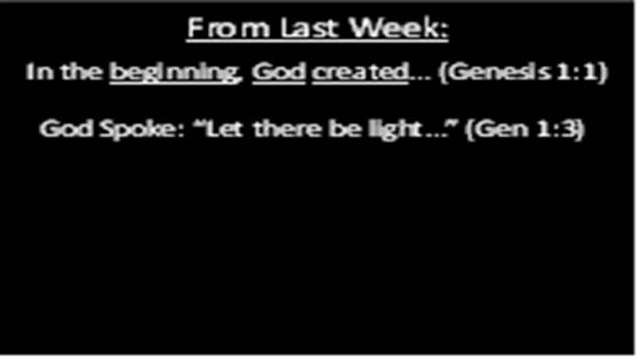 | Last week, we saw three important things in Genesis 1:1 – In the beginning, God, and created. In verse 3, we saw the first example of what God often does – He sends forth His word into darkness, bringing light (physical and spiritual).
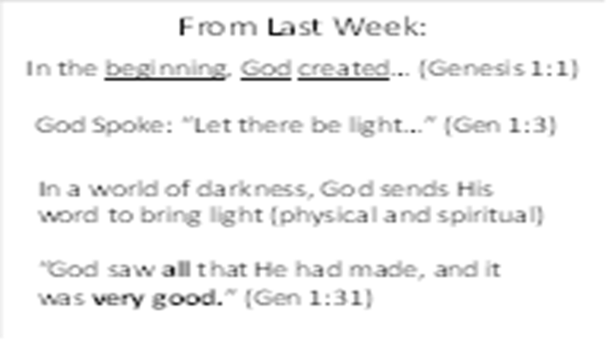 | Also, Genesis 1:26 shows us how God made people special: in His image. He gave them a mind, a will, emotions, and authority. God created us in His image so that we might know Him personally.  We ended by looking at Genesis 1:31 – God made a wonderful world, a beautiful garden (Eden), and created people in his image for an unhindered relationship with Himself. It was all “very good.” But when we look at our world today, it is far from perfect.
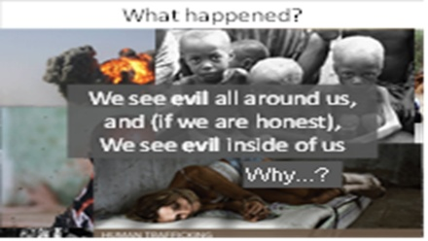 | We see evil all around us: terrorism, abuse, disease, and death. And if we’re honest, we sense the evil within us: greed, lying, lust, and rebellion. What happened?
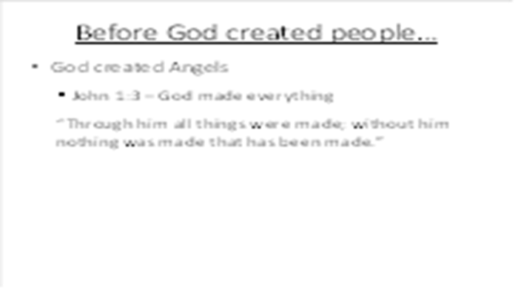 | Remember: God is the creator of everything that exists. When you back up into eternity, He is the “Uncreated One,” the “first cause” of everything else that exists.
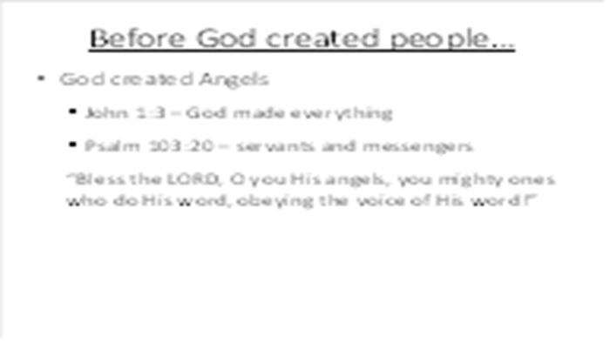 | Even before God created people, He created “spirits” to be His servants. God is greater than the spirits - He lived before them eternally, He made them, He gave them life. Spirits do not have physical bodies, like us - they can move about wherever they want to. In the beginning, the spirits were all God’s angels. Angels means “messengers” or “servants.”
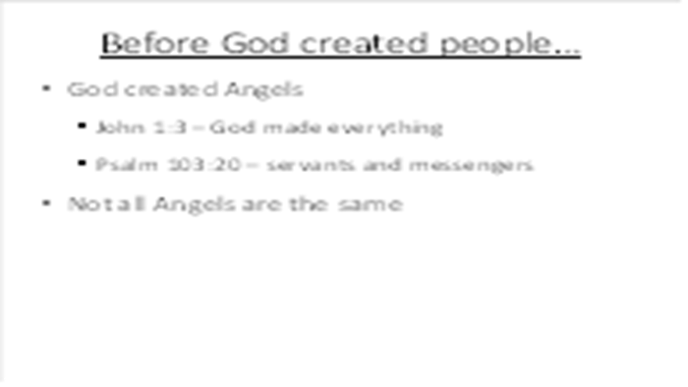 | God didn't create all the spirits exactly the same. Some were more beautiful, some were more powerful than others.
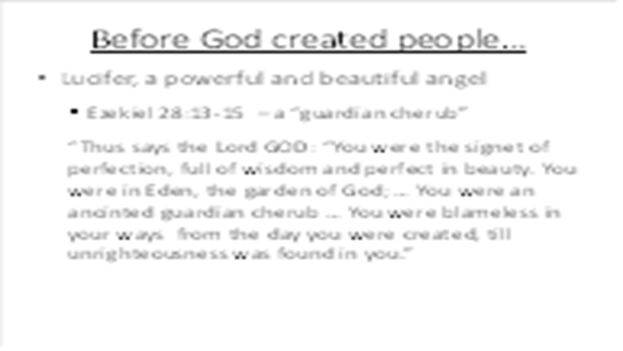 | The greatest angel was called Lucifer. Lucifer means “morning star.” God does not create evil – everything He makes is perfect.
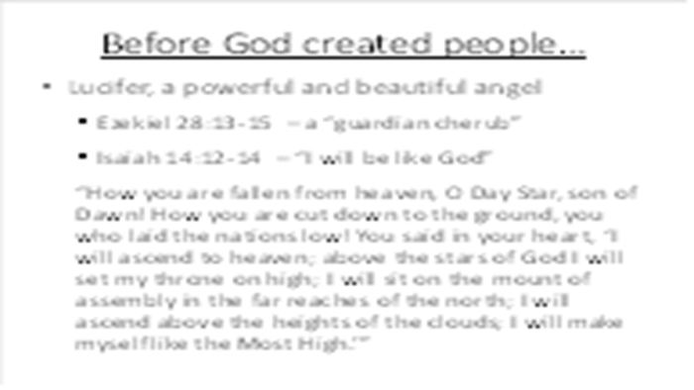 | God gave Lucifer a place of great authority over the other angels in Heaven. Lucifer was created blameless and perfect, but after a time, Lucifer became proud of his beauty and position and wanted to be “like the Most High.”
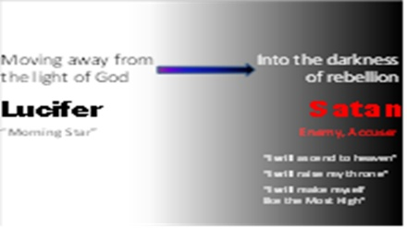 | God is perfectly good. But when a creature chooses to go their own way, they move away from His light into darkness, choosing to be their own god. Lucifer was the first one to do this evil, an action for which he has been judged and will be condemned. Lucifer is also called Satan which means “enemy, adversary, opponent, or accuser.” Other angels followed Lucifer in his rebellion, and are now called demons. (2 Peter 2:4)
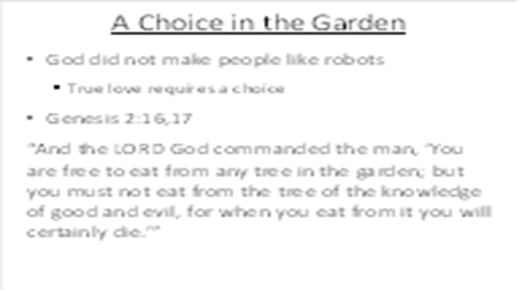 | Because Adam was created in the image of God, he was given a will – the ability to choose obedience or disobedience. Therefore, God gave him the privilege to eat from any tree in the entire garden except for one: Genesis 2:16,17  God could’ve created Adam and Eve like the animals or like robots, only programmed to do good. But true love requires a choice, so he gave people a will – the ability to choose to follow or reject His leadership.
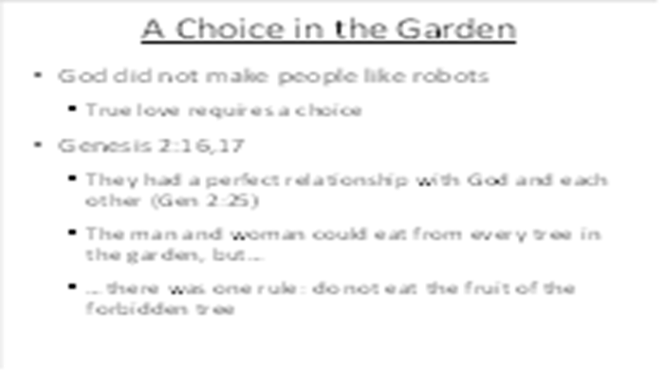 | As we said above, life in the Garden of Eden was very good – perfect. Adam and Eve had everything they needed. God put Adam in position of manager over all the creation. God gave them a variety of plants and fruits and vegetables to eat, and they had a perfect friendship and fellowship with God and with each other (Genesis 2:25).
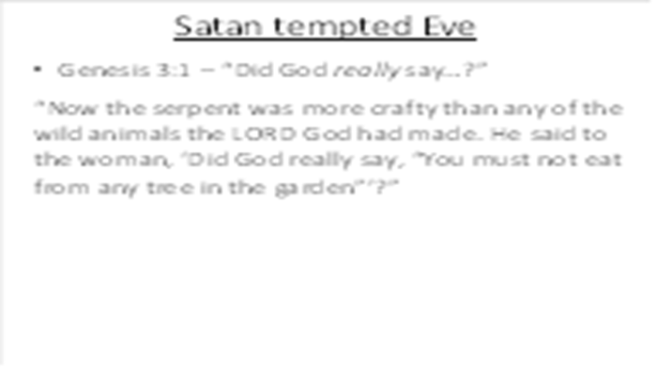 | Satan knew about God’s warning to Adam concerning the one tree. Because Satan hates God, he wanted to destroy the man and woman God made in His image. Therefore, Satan planned to deceive Eve.  Genesis 3:1 Why did Satan ask Eve this question? – Two reasons: to create doubt about the truthfulness of God’s word, and to tempt them to think that God really didn’t love and care for them.
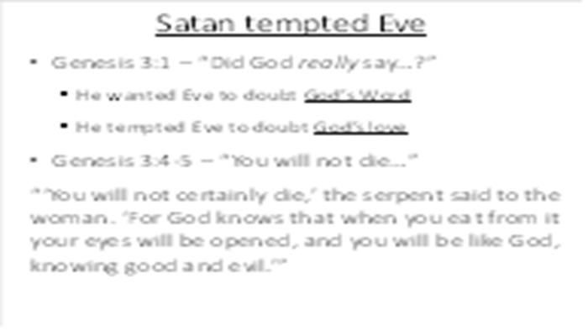 | Satan is a deceiver. He tries to make what is good appear useless or evil, and what is evil appear good. Satan deceived Eve by coming to her in the form of a snake. Up until that time, the animals had not been harmful in any way to Adam and Eve or to each other, so Eve was not afraid (2 Corinthians 11:14).  Genesis 3:2-5 Satan had already rebelled against God’s authority. He wanted to be independent of God and rule his own life. Now Satan was suggesting to Eve that she should also rebel against God. Satan said that eating the fruit would make Eve like God in knowing good and evil. Satan wanted Eve to believe that she wouldn’t need God to tell her what was right and wrong. But the truth is that God did not make people to live by their own ideas and thoughts, and He made us to be guided by His own Word.
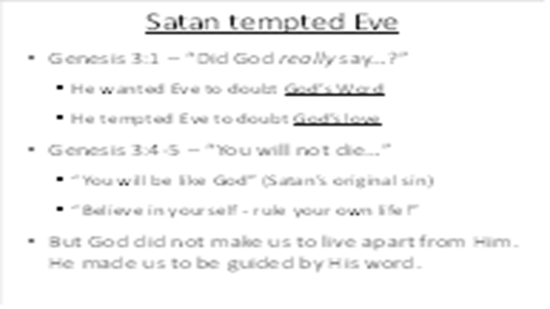 | Remember – they were already created in the image of God. Satan’s temptation to “be like God” really meant to “be like God”!  Perfect freedom does not come from the absence of wise rules…
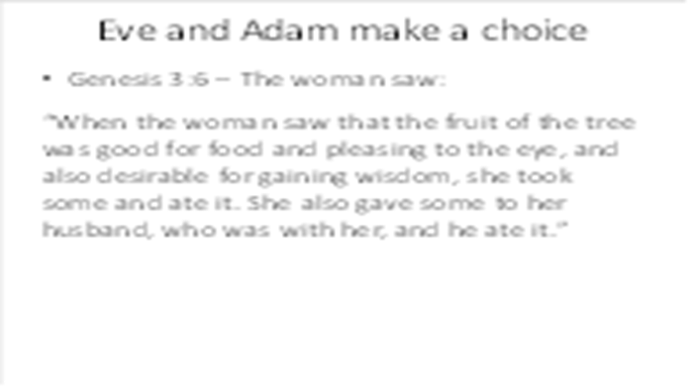 | Genesis 3:6 What did God say would happen to them if they ate of the tree? – He told them that they would die. Even though Adam knew that God had said not to eat it, he deliberately disobeyed God’s command. Adam turned away from depending on God. Up to this point, he had personal experience with the goodness of God. Now, because he had chosen to follow Satan, he will become personally familiar with evil.
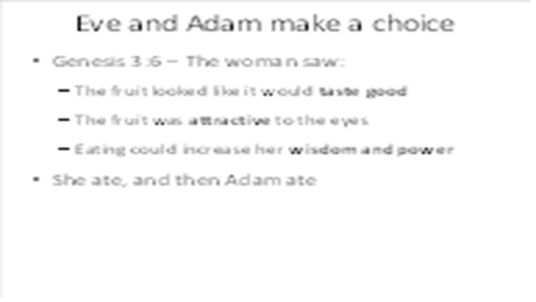 | The Bible has an amazing consistency from beginning to end. We face these same three temptations today, ones which are described in 1 John 2:16 – the lust of the flesh, the lust of the eyes, and the boastful pride of life.
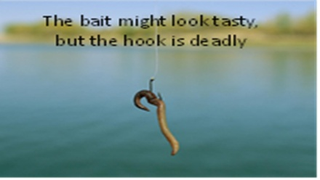 | If we rush into sin without stopping to look for the hidden danger, we can find ourselves hooked and on the pathway to death.
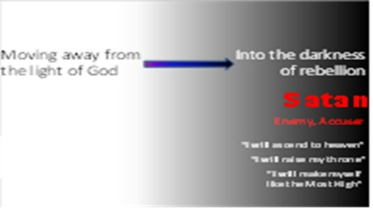 | Sadly, the man and woman followed Satan’s original path into sin, choosing to rule their own lives instead of submitting to the loving authority of God.
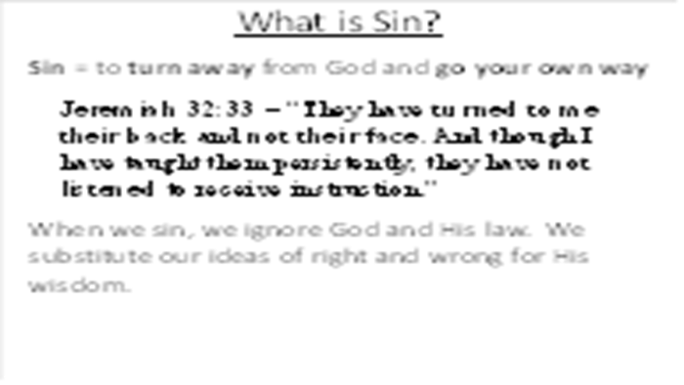 | It might be small thing to ignore the request of a friend, but it is a dangerous thing to ignore the request of our boss (or our president). The evil of sin becomes even more clear when we consider the level of authority of God, the One we have truly offended!  God created us – He has complete authority!  When we choose to follow our own earthly ways, we decide what is right or wrong based on ourselves and our culture.  Idolatry = putting our trust in that which is not God (usually, ourselves)  Psalm 14:1-3 shows the root of our sin: ignoring God, turning aside from Him: “The fool says in his heart, “There is no God.” They are corrupt, they do abominable deeds, there is none who does good. The LORD looks down from heaven on the children of man, to see if there are any who understand, who seek after God. They have all turned aside; together they have become corrupt; there is none who does good, not even one.”
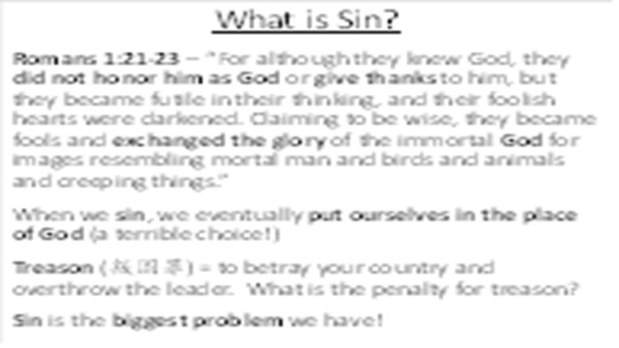 | People create their own gods and methods of salvation to maintain control over the process (we want to retain authority). Although we might not think that we are taking the place of God, it becomes clear when we define our own morality, meaning, and salvation method.  叛国罪 The normal penalty for treason is death! (Romans 6:23)  Sin: the biggest problem of every human being!
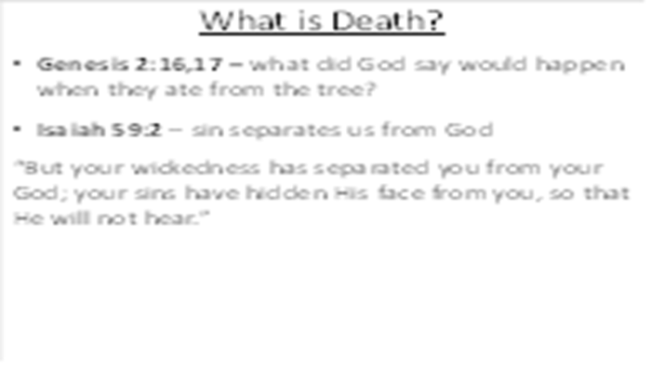 | When something dies, it becomes separated from the source of life. Physical death is the time when a person’s spirit is separated from their body. Spiritual death is the time when a man becomes separated from God (Isaiah 59:2).
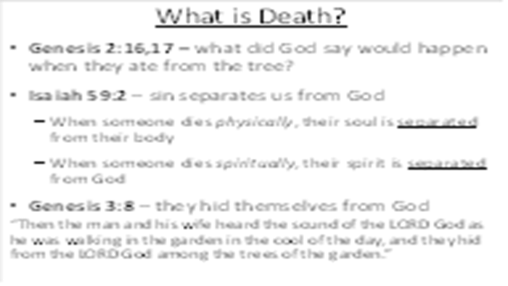 | The first sign of separation from God we read about is that they tried to hide from God.
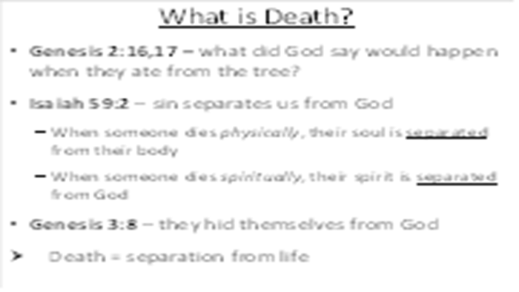
 | They are cut off from the source of life…
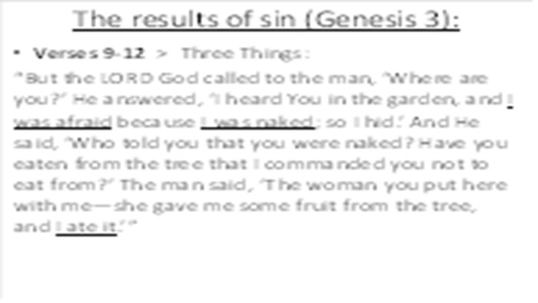 | Could God see where they were hiding? Why did God call out? – He loved them and wanted to give them an opportunity to confess their sin. We are responsible for our actions. Do you think God needed to ask them to find out what happened? No, but He was giving them an opportunity to agree with Him that what He said was truth and that they were wrong in believing and following Satan.
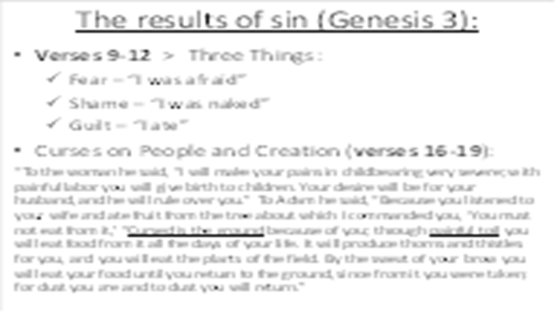 | When Adam and Eve sinned, three things happened to them: fear (I was afraid), shame (I was naked), and guilt (I ate). All over the world, we see these three results of evil.
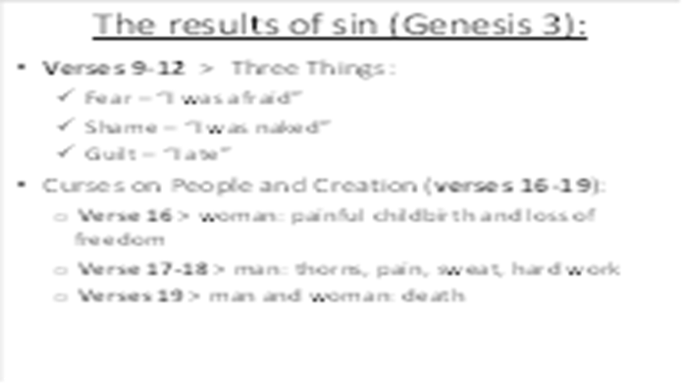 | When God created Adam and Eve, He did not intend for them to die. Even though man did not die physically on the day that he ate from the tree, his genetics were now changed, eventually leading him to physical death. Death would now be routine for everything on earth.
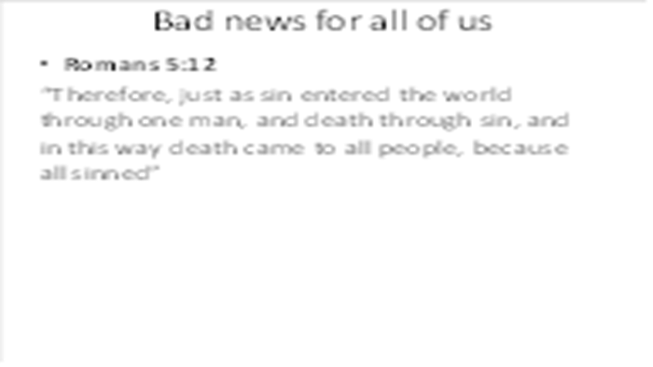 | The sin of Adam and Eve has been passed down to every human being on the planet. Just like you “inherit” genetics from your parents, we have all inherited sin and death from Adam and Eve. No child is born good – all are born with a sinful nature (that’s why parents have to teach their kids to do good – they naturally do bad).  “Behold, I was brought forth in iniquity, and in sin did my mother conceive me.” Psalm 51:5
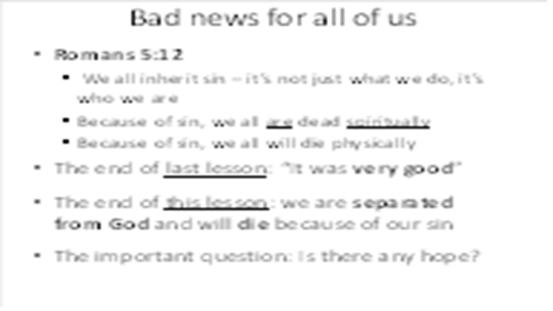 | Even though tonight’s lesson began with the words “very good,” it ends on a very sad note: men have been separated from God and are now destined to live in a cursed world of evil and death. The question is this: is there any hope for mankind?
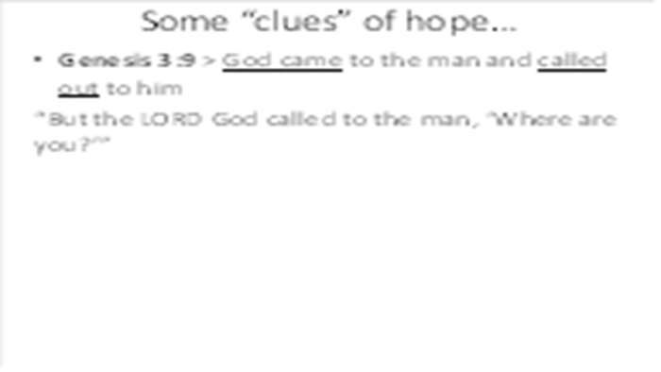 | The answer: yes, there is hope found in two clues above:  God had every right to destroy the people He created: they were guilty and had corrupted His perfect world. But even when man was hiding from God, God came to the man and called out to him, giving him an opportunity to admit his sin and seek forgiveness.
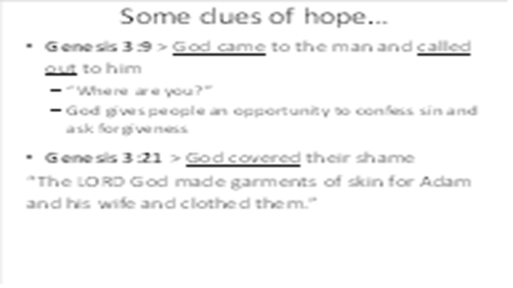 | Even when man was hiding from God, God came to the man and called out to him, giving him an opportunity to admit his sin and seek forgiveness.  And instead of punishing the man, God killed an animal as a substitute in order to cover the shame of the man and woman.
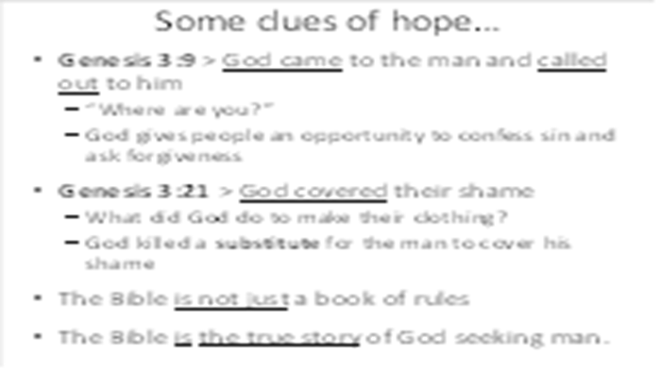 | Now that you understand the problem of death, it helps you to better understand the message of the Bible. It is not just a book of rules to try and help sinful people get along better with each other. It is the story of God seeking man. It is the amazing story of what God will do to restore His relationship with people who turned away from Him.
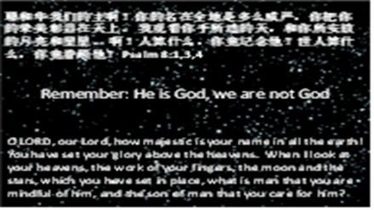 | As we conclude, I want you to remember an important fact, one that Satan confused in the mind of Adam and Eve: God is God and we are not God Psalm 8:1,3,4  He is the center of all things, and we only exist because He has chosen to make us. When we keep our attention clear about this, it changes everything!

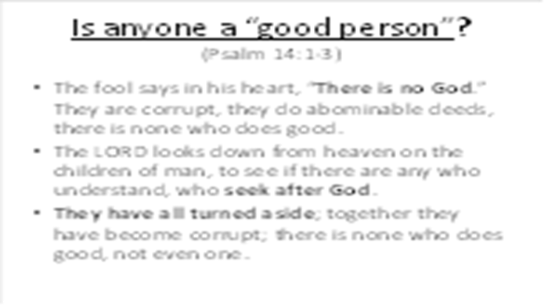 | Psalm 14:1-3 shows the root of our sin: ignoring God, turning aside from Him
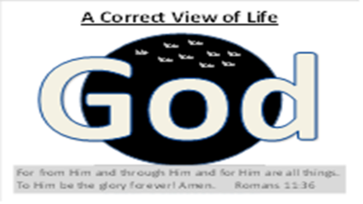 | The right view of Life: God is at the center of all things. I was not created to be self-centered, I was created to worship and enjoy God forever.
