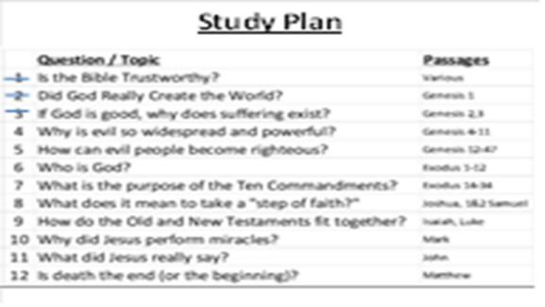
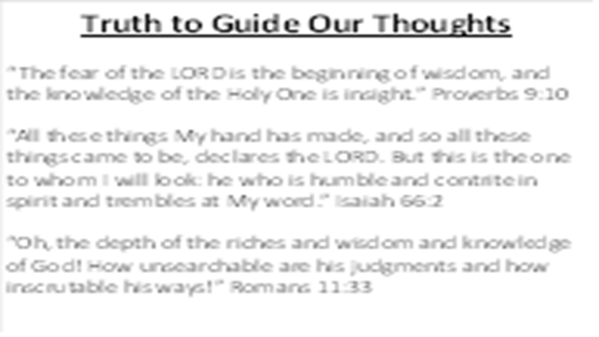 | As we begin today’s lesson, it is important to remember important truths about God. He is at the center of every part of the Biblical story (not us). If we get this backwards, we quickly move away from truth and add Him to our story, leading us away from His light and into our darkness.
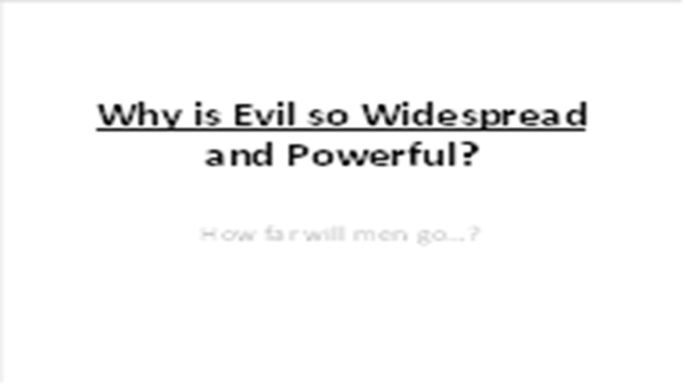 | In our last lesson, we saw how evil entered into the world, removing Adam and Eve from the Garden of Eden and from the presence of God. Today, we will see how quickly evil spreads and “infects” everything and everyone.
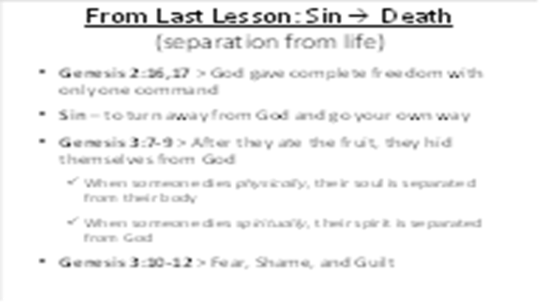 | In review of our last lesson, we saw that Adam and Eve chose to disobey God. The result of their actions was spiritual and physical death: separation from God, and ultimately, separation of life from their bodies. In the first few pages of the Bible, we have discovered the cause of suffering and death - sin. The greatest sin of all: rejecting the almighty God. Separation from the source of life itself.  The remainder of the Bible contains the amazing story of how God is seeking to bring people back into a perfect relationship with Himself.
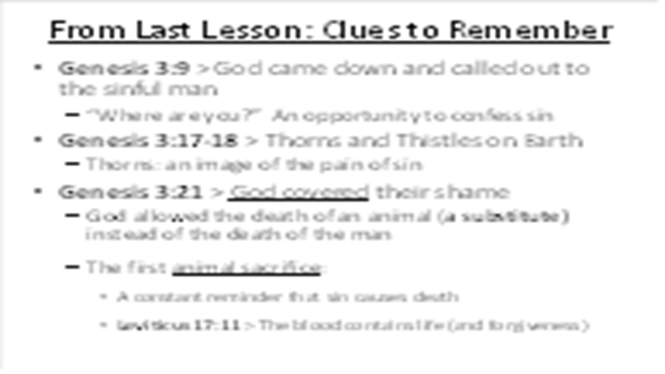 | As I mentioned last time, the Bible tells the amazing true story about what God is doing to bring people back to Himself. As we move through the Old Testament, we will see “clues” of how He will rescue lost people, starting with these three from Genesis, chapter 3:  1) While God could have instantly killed the man for his direct disobedience, He didn’t. Instead, He came down to the sinful man, calling out to him, giving him the opportunity to repent  2) Because of sin, life on earth became very difficult. We see thorns and thistles grow up where good fruit should have been. We didn’t focus specifically on this last week (as a clue), but you will see later that thorns are a painful reminder of sin.  3) And in a world created with beauty and life, we see the first deaths: God killed animals instead of the man and women, a substitute death to cover their sinful shame.
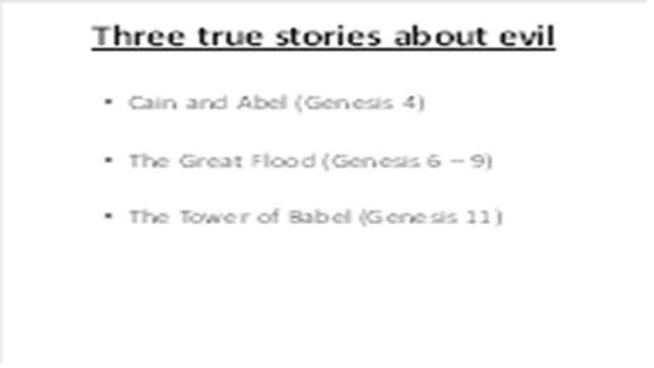 | In this lesson, we will look at three true stories which show us how far men will go away from God. Unless God restrains evil, it will quickly consume us (and we will consume each other).
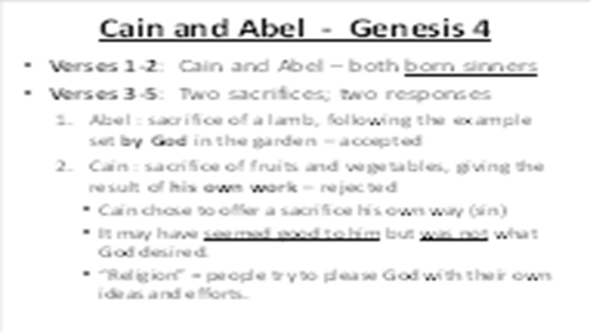 | Since Adam and Eve were both sinners, they passed their sinful genetics down to all of their children. Since both of their sons were separated from God by sin, they offered sacrifices to try and please God. In the garden, God had set the pattern of sacrifices by killing a lamb to cover the sin and shame of Adam and Eve. But Cain decided to do something different. He was a farmer and chose to offer his best vegetables to God. To him, this seemed like a good thing – giving your best to please God,  But God had already set the pattern of the right thing to do – the blood of the lamb was needed. Even though the animal sacrifice could not take away their sins, it demonstrated agreement with God’s truth that sin results in death. In pride, people try to please God with their own ideas and efforts – we often call this “religion” – man’s effort to save himself.
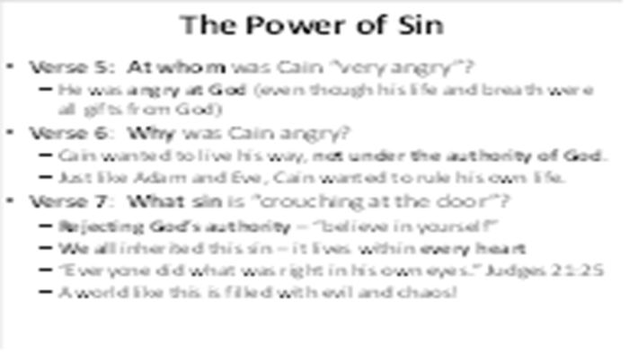 | This story is not just about Cain and Abel – it is about all of us. As we read these verses, examine your own heart and you will see that we all face the same sinful temptations. Why is evil so widespread? Because this same sin resides in the heart of every person!
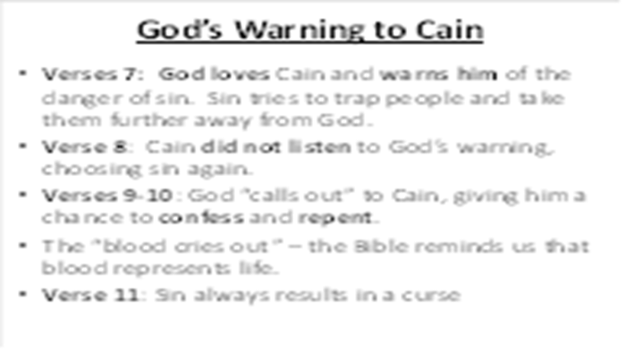 | Note that God is warning Cain about the temptation to add one sin to another. Warnings demonstrate love. When we love someone, we warn them against danger.  Sin isn’t a passive enemy – it actively pursues people, taking them further away from God. But Cain already had a plan to cover up his sin…  Why does God call out to Cain? – Once again, we see God giving man an opportunity to confess and repent. We also see another reminder that blood represents life – figuratively, it cries out from the ground. Cain was cursed for his actions, made to be a “fugitive” on the earth (separation).
 | We have a very sinful tendency to drag God’s glorious majesty down to human level (Psalm 50:21). When we do this, we assume that we can satisfy His expectations with our religious activities. But the actual fact is much more serious – our only hope is to submit completely to His way.  When we forget God’s holiness and awesome greatness, we move from an accurate fear of the Lord (Proverbs 9:10) to acting as though He needs our collaboration (Isaiah 40:14). Like Cain, we demonstrate our rejection of His definitions of good/evil and replace them with our own.  Inventing religions is a global practice, but it does not solve our problem with sin.
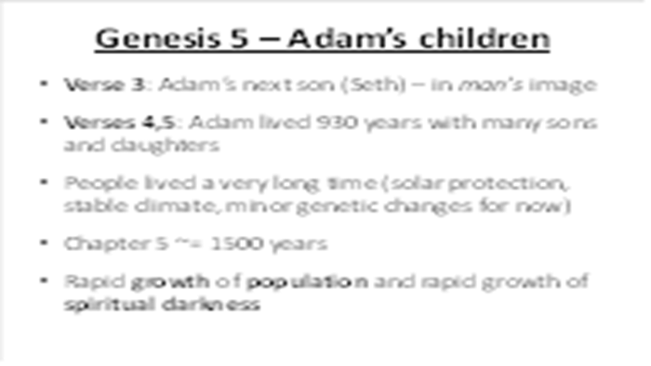 | The sad change: Initially, men were created in the image of God, but now, they inherit the sinful genetics of their parents (all the way down to us).  While the lifespans of people in this chapter seem impossibly long, recognize that the early earth had a very different climate and that the sinful effects on human genetics were only beginning.
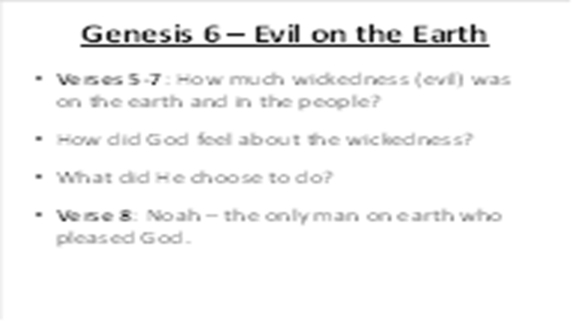 | Notice that God sees the actions of mankind and the condition of their hearts. How did God feel about the wickedness on the earth?  God is creator, owner, and absolute authority of everything and everyone that exists. He had every right to destroy His creation and would be perfectly just to do so.
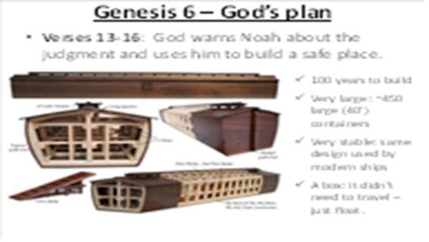 | In Genesis 6:13-22, God tells Noah that He is going to destroy the people on the earth as well as the earth itself. God tells Noah to make an “ark” – a huge barge. God tells him exactly what to do, designing a very stable vessel. Over the next 100 years, Noah did everything just as God commanded.
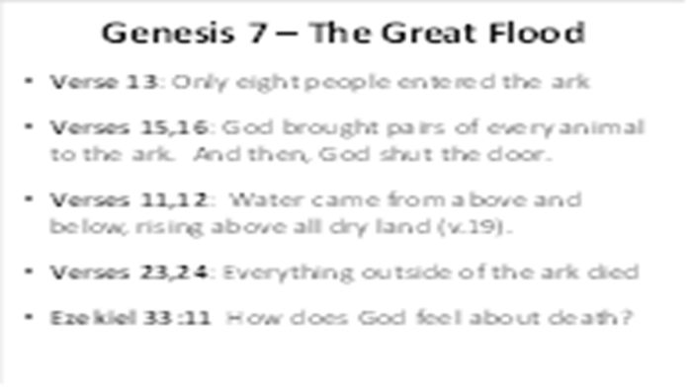 | On the appointed day, God brought the animals to Noah’s ark and shut them inside. As the global flood approached, this was the only safe place on earth.  In verses 17-24 we learn that the water came from above and below the earth (verses 11,12) for 40 days, covering the mountains to a depth of more than 7 meters. Every person, land animal, and bird that was not inside of the ark died. The waters flooded the earth for 150 days.  Ezekiel 33:11 tells us that God does not take pleasure in the death of the wicked (He did not laugh at their destruction). God’s justice is always fair.
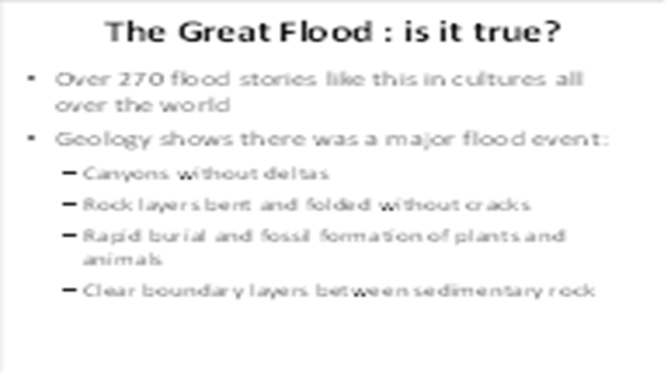 | This story is not isolated to the Bible – there are over 270 flood stories like this in cultures all over the earth. Much evidence from geology shows that there was a major flood event, including canyon formation without deltas, clearly defined layers of sedimentary rock, folded without cracking, and rapid burial/fossilization of plants and animals (including ones that penetrate multiple layers of rock). I can share more information later if interested.
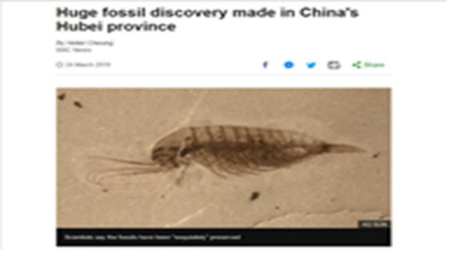 | A recent discovery in China shows the same reality that is found all over the world – geology indicates a massive flood event that resulted in huge, mixed fossil deposits all over the world.
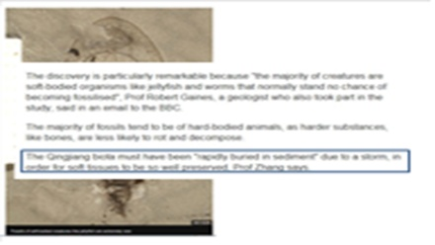 | What does it take to make a fossil? When an animal or plant dies, it lies on the ground (or just under the surface) and rots away.  To make a fossil requires rapid burial, high pressure and very special conditions. Like those in the great flood…
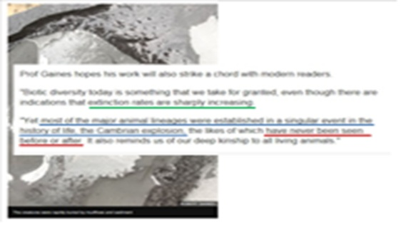 | It is interesting to consider the fact that, every year, we see thousands of species go extinct, but we never see new ones emerging (i.e. we don’t see evolution happening, we see the opposite).  I love their conclusion: a singular event caused the establishment of all these creatures (and all of these diverse fossils), and it was one that had never been seen before or would be after.
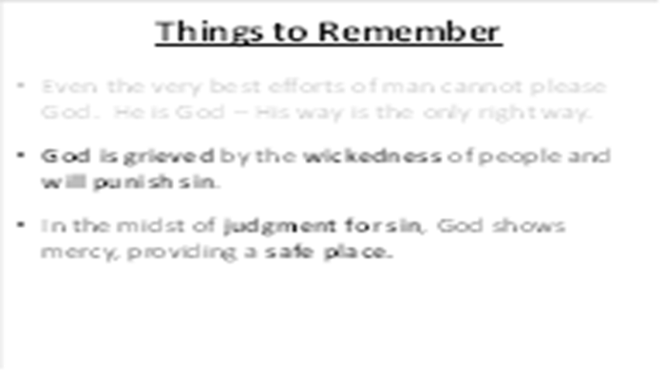 | When the Bible talks about “the heart,” it’s not just talking about our feelings – it also refers to our thoughts and the decisions we make. While we can hide from people, God sees the heart of every person and knows the truth of what we might try to hide.  Since God made us and loves us, our sin causes God sorrow. He knows that our sin takes us further away from Him, leading us to darkness, death, and ultimately, judgment.  Throughout the Bible, you will see stories of God showing judgment and mercy (e.g. warning Noah and closing the door). Here, we see another clue about God’s plan – in the midst of judgment, He provides a safe place for men to survive. But the only safe place of survival is the one that He provides.
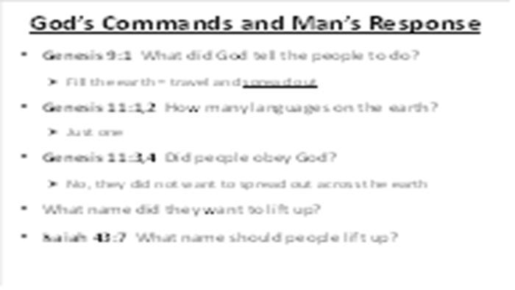 | After the flood, were people better? No, the inclination of the human heart is still evil.  What command did God give to Noah and his descendants? – God told the people to multiply and spread out over the earth. But man ignores God and desires to do their own thing…  What does this say about the language on the earth at that time? (maybe everyone spoke Chinese ). What did the people want to do and why did they want to do this? God told them to spread out, but they wanted to stay together to make a name for themselves.
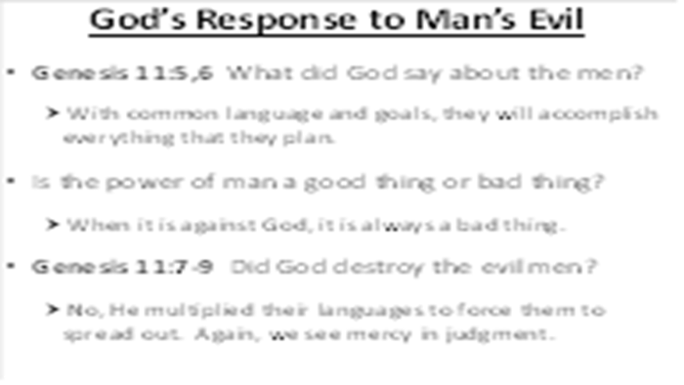 | Who is the “Us” in verse 7? What did the Lord say about the people’s plan? What was the result of God’s introduction of confusion? Once again, the people directly disobeyed God. Why didn’t He just destroy them? This is another good example of God balancing His judgment with His mercy. When I struggle to learn the Chinese language, I must remember that our language difference is a result of His mercy!  The people gathered there because they did not want to be scattered over all the earth as God commanded. These men were full of pride! They should have been interested in exalting God’s name, not their own.
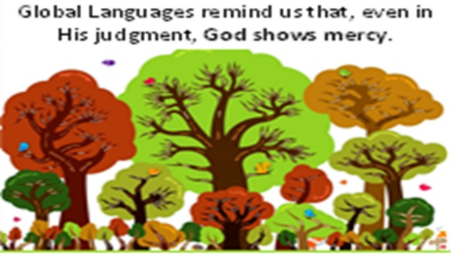 | Linguists tell us that, apart from this story of Babel, there is no good explanation for the diversity of languages that exist on the earth.  Studies have determined that there are about 6900 distinct languages around the world, originating from about 15 unique “protolanguages.”  Studies have also shown that, over time, language tends to devolve from complex to simple, not the other way around.
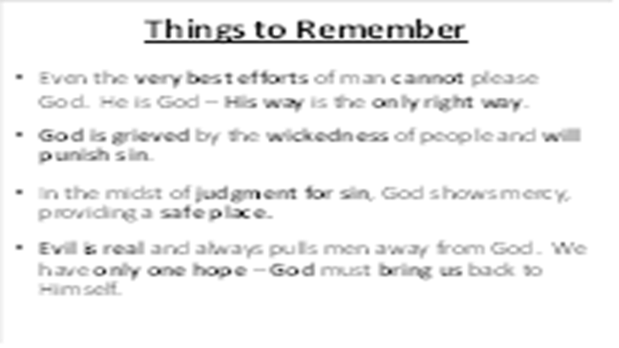 | As I said earlier, the most serious sin of all is to reject the Creator God of the universe. When we choose to seek our glory instead of His, we are actually doing just that – putting ourselves into His place, making ourselves God.
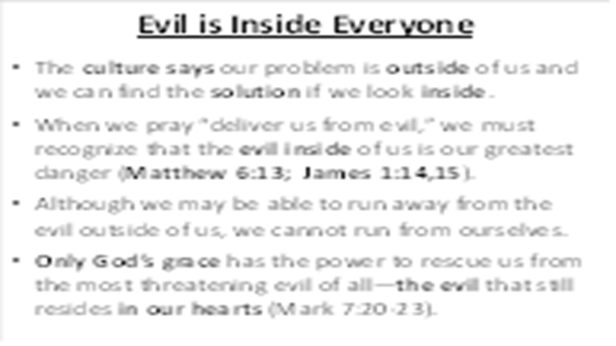 | Modern psychology assumes that our big problems are outside of us: societal pressures, financial hardships, unfairness, drugs and alcohol, temptations, etc. It then tries to reach inside of a person and use their “inner strength” to achieve a solution.  But this is not the reality we experience and is certainly not the message of the Bible. The Bible is clear that we all are born with a sin nature, attracting us to opportunities for sinful actions around us.  Our sinful nature (on the inside) can only be overcome by a greater power from God (on the outside).
Yes, there is evil (bad news). But there is also hope.
Remember Ezekiel 33:11 – God does not take pleasure in the death of the wicked. He has a plan to rescue sinful people…

