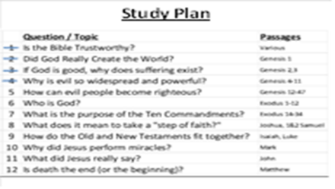
 | All around us, we feel the darkness of sin, and if we’re honest, we feel the sinfulness inside of us. In today’s lesson, you will see how God used a small nation in the Middle East to provide a permanent solution to this problem.  The OT prophet Ezekiel said that God would do this: “And I will give you a new heart, and a new spirit I will put within you. And I will remove the heart of stone from your flesh and give you a heart of flesh. (Ez 36:26) How could this happen? Today’s lesson cracks open the door to this wonderful hope!
 | Our last lesson showed us that, although God created people for His glory (Isaiah 43:7), people seek after their own glory (Genesis 11:4). God continues to call men back to Himself, but they quickly drift away. It is quite clear: people, in their own strength, are not capable of returning to God.
 | We begin by looking at the historical record of Abraham in Genesis 12:1-3. The story begins about 2100BC, just before the start of the Xia Dynasty (2070-1600BC). In verse 1, what did God tell Abram to do? We see that Abram was told he was going to go into a different land where none of his family lived. Can you imagine how hard it would be to tell you family that you were going to follow God, but didn’t really know your exact destination? This would take a huge amount of faith (Hebrews 11:8).  In verses 2-3, what did God promise to Abram? God promised that He would bless Abram, and Abram would be a blessing. How could one man and his descendants be a blessing to all families of the entire earth? We will soon see that a distant relative of Abram’s would be a very special child from God.  According to Deuteronomy 7:7, God chose this nation because they were not large and powerful. Otherwise, they would boast about themselves instead of God. This is a pattern that emerges in the Bible – God doesn’t choose the strong and powerful person or nation – He chooses the weak and empowers them to carry His plan forward.
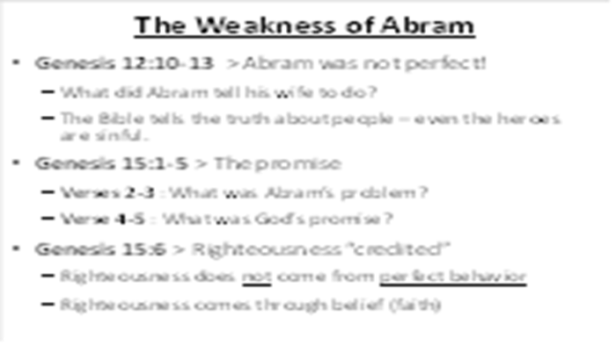 | But Abram was not a perfectly good man – he was sinful. When his journey takes him to Egypt, he is afraid and lies about his wife (Genesis 12:10-13). Here is something that you will see in the Bible – it is not a book of legends about perfect heroes – it is the true story of real people used by God.  If Abram was sinful, how could he be a blessing to the entire world? God made a very important promise to him in Genesis 15:1-5. Even though it was humanly impossible for him and his wife to bear children, God promised a miracle (a supernatural act). And in Genesis 15:6, we learn a very important truth: righteousness does not come from perfect behavior – it comes from faithful belief. The word “credited” is a financial term, meaning to transfer something from one account to another. There is only one way to have something as valuable as righteousness: God must transfer it from His account to ours.

 | God also reveals something else to Abram in Genesis 15:13-14 – his descendants will suffer as foreigners for 400 years, and then be set free by God’s judgment. Keep this in mind for our next!  Abram was 99 years old when God changed his name from Abram to Abraham. Abraham means “father of a multitude of children.” God also changed Sarai’s name to Sarah. Sarah was 90 years old when God changed her name, meaning “mother of many nations.” (Genesis 17). And finally, in Genesis 21:1-5, we see that God gave Abraham and Sarah a son. Abraham named his son Isaac. Abraham was 100 years old when Isaac was born.
 | But then, in Genesis 22, God does something entirely unexpected. In verses 1-2, God tells Abraham to take his only son and offer him up as a sacrifice. This is shocking for (at least) two reasons: first, throughout the Bible, God always condemns human sacrifice. And second, this is the child of promise, the one through whom all nations would be blessed. How could Abraham do something like this to his special, only beloved son? But look at his response in verses 3. Abraham obeyed God right away? Here is evidence of Abraham’s faith.  The three day journey gave Abraham plenty of time to look at his precious son Isaac and change his mind. A couple of servants came along to help, but when they reach the mountain, Abraham asks them to stay behind (22:4,5). He makes a bold statement to those he leaves behind: “We will worship and then we will come back to you.” Even though he was expecting to kill and burn Isaac, he believed that, somehow, God would bring him back alive. In fact, look at Hebrews 11:17-19 for confirmation of what Abraham was thinking. Even though Abraham did not understand what God was doing (or how, or why, etc), he acted in faith.
 | So Abraham puts the wood on the back of his son Isaac and they climb the mountain (vs 6‑8). What did Isaac ask his father and what was Abraham’s answer? When Isaac asked about the lamb for the sacrifice, Abraham told him the truth: that there would be one provided. At this point, Isaac was a strong young man, trusting and submitting to the will of his father.  In verses 9-12, Abraham does exactly as God commanded, but God stops him at the last second. Why did God stop Abraham – what had he proved to God? God wanted Abraham to show how much he feared God. Abraham obeyed God by being willing to sacrifice his only son. God was having Abraham act on his faith. And as promised, God provides a sacrifice Himself (vs 13‑14). Here is another important clue to remember: the only son of a Father climbed a mountain with wood on his back as a sacrifice, and he speaks of the future by claiming that “the Lord will provide.”

 | When Isaac was 60 years old, he and his wife Rebecca gave birth to twin boys. The first one born was red and hairy so they named him Esau and the second one was named Jacob. God planned to pass on the promise of blessing through Jacob. Jacob has an important dream in Genesis 28:10-14, seeing a stairway into heaven and the glory of God (a clue of a future event!). He then receives the same promise as his grandfather Abraham. But Jacob was also a sinful man, tricking his father, brother, and father-in-law. By now, we are learning that God uses imperfect people (like us) to accomplish His perfect plan.  Jacob had 12 sons from 4 wives. The names of Jacob’s sons are Reuben, Simeon, Levi, Judah, Issachar, Zebulun, Joseph, Benjamin, Dan, Naphtali, Gad, and Asher. Later on, God changed Jacob’s name (deceiver) to “Israel” (one who wrestles with God).

 | Let’s continue the story by reading about one of Jacob’s youngest sons, Joseph (Genesis 37:2-4). We start off by seeing two problems: Joseph is proud and says bad things about his brothers, and Jacob shows favoritism to Joseph.  Although his brothers hate him for his pride, Joseph continues to boast (Genesis 37:5-8). Their anger grows, until one day, they take action.  In Genesis 37, Jacob tells Joseph to check on his brothers who were watching the flocks far from home. When his brothers saw him, they decided to kill him (verses 19-20). But then they changed their minds and decided to sell him as a slave (verses 25-28) for 20 shekels of silver. To cover up their actions, they bloodied Joseph’s coat and brought it back to their father (vs 31‑33). As you can tell, the sons of Israel were just as sinful as everyone else.
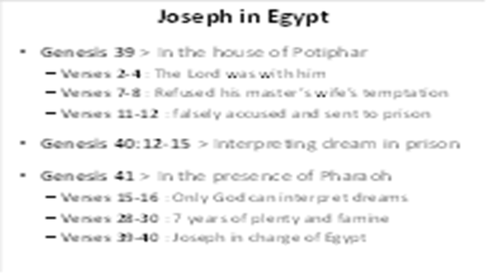 | In Genesis 39:1-2, we see that Joseph was sold to Potiphar, an Egyptian who was one of Pharaoh’s officials. Potiphar noticed that God was with Joseph, so he put hm in charge of his household with everything he owned. But Potiphar’s wife made false accusations against Joseph and he was put into prison. The prison warden also noticed that God was with Joseph and put him in charge of all those held in the prison. Two of the prisoners were a cupbearer and a baker. Genesis 40 tells us about these 2 men having dreams, and Joseph interprets them through the power of God. Just as Joseph said, the cupbearer was released and started to work for Pharaoh again, but the baker was killed. Joseph asked the cupbearer to remember him once he was out of prison, but he did not.  In Genesis 41:1-8, we see that 2 years passed since the cupbearer had been released. Pharaoh had a dream, but none of the wise men of Egypt or any of the magicians he asked could interpret the dream. Then the cupbearer told Pharaoh about the dream he had while in prison and how Joseph was able to interpret it. So Pharaoh commanded Joseph to be brought to him from out of the dungeon (Genesis 41:15-16). Could Joseph give the answer in his own power? Notice how Joseph changed during his time as a slave and in prison – he is no longer proud and self-centered but is humble and God-fearing (1 Peter 5:5-7).  In Genesis 41:25-32, Joseph interpreted Pharaoh’s dream. Joseph told Pharaoh that seven years of great abundance are coming throughout the land of Egypt, but seven years of famine would follow them. Joseph encouraged Pharaoh to carefully save grain to prepare for the famine, so Pharaoh made Joseph second in command over all of Egypt (vs 39,40).
 | The famine was also a problem back in the land of Canaan. So Jacob recommends that his sons go there to buy grain (Genesis 42:1-3). Joseph was now a high official in charge of selling grain. So when Joseph’s brothers went to Egypt, they had to deal with Joseph. Joseph recognized his brothers, but he pretended to be an Egyptian stranger (verses 6-9) and they did not recognize him.  In order to test them, Joseph keeps one of the brothers as a prisoner (Simeon) and sets the others free. Even though it was many years ago, the brothers still carry the guilt of what they did to Joseph (Genesis 42:21,22).  They return to their home country but soon come back for more grain. This time, Joseph tests to see if they will betray their youngest brother, but Judah offers himself as a substitute (Genesis 44:33), indicating that a future substitute will arise from his offspring. It appears that there has also been a change in the heart of some of Joseph’s brothers.  It was now time for Joseph to reveal his true identity (Genesis 45:3-9). Rather than treating his brothers as their deeds deserved, Joseph explained to them that God was in control of the situation, and that He had used the brothers’ horrible actions to work for good. Then Joseph’s brothers went back to their home country and told their father these things. Jacob then moved the whole family and all of his possessions to Egypt.  In order to show his gratefulness for Joseph’s blessing to Egypt, Pharaoh welcomes them to live on their very best land. But the Egyptian kings will not always be kind to the sons of Israel…

 | God knows what is going to happen. God always keeps His promises. Many years before, God had told Abraham that his descendants would go to another country. And now, they have become guests of the land of Egypt.  As the book of Genesis closes, please notice two important promises:  Genesis 49:10 – the Ruler of nations (the blessing from Abraham) would descend from the offspring of Judah  Genesis 50:24-25 – God will come to the aid of the Israelites and deliver them from Egypt
 | Remember that God is guiding the events of history, preparing a way to restore the broken relationship with Himself. In spite of the sinfulness of man, God is still in control and will accomplish His purpose (Isaiah 25:1; Job 42:1,2).

