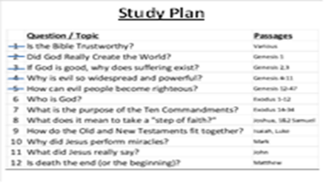
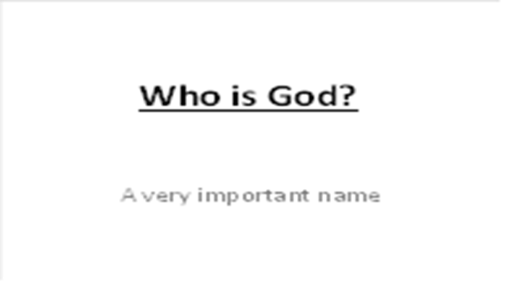 | This is our 6th Bible study together. So far, we’ve seen how the world was created by a God with amazing power. We saw how He made people in His image and for His glory. We also saw that the first people chose to disobey God (“sin”), and as a result, all people were separated from God and will die. And even when God calls people back to Himself, they quickly drift away into wickedness.
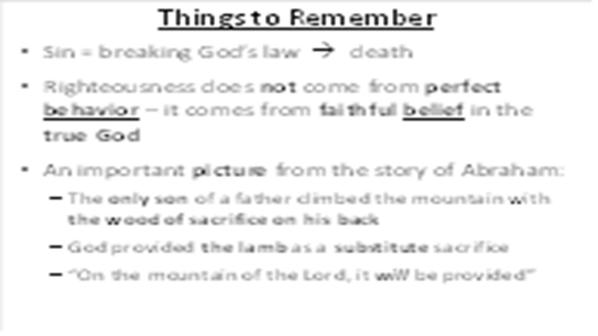 | I always want to remind people of the two big problems facing all of humanity. The first one is that sin leads to death for all people (physical and spiritual) and the second one become clear next week.
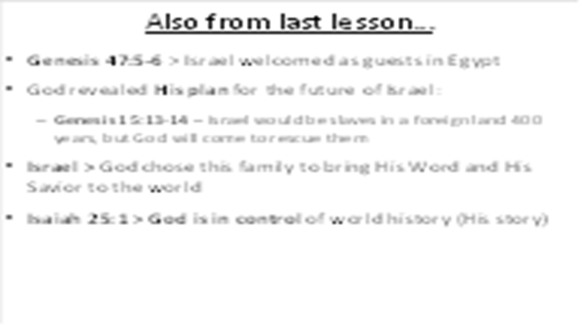 | As I’ve said before, the Bible is not a book of rules to help sinful people get along with each other – it is the true story of a loving God who is reaching out to bring sinful people back into a relationship with Himself.  Last week, we saw how God chose a man named Abraham to follow Him, making a promise that one of his descendants would become a blessing to all nations. His grandson, “Israel,” (Jacob) moved his entire family of 70 people to Egypt at the kind invitation of Pharaoh, settling in the best part of land.
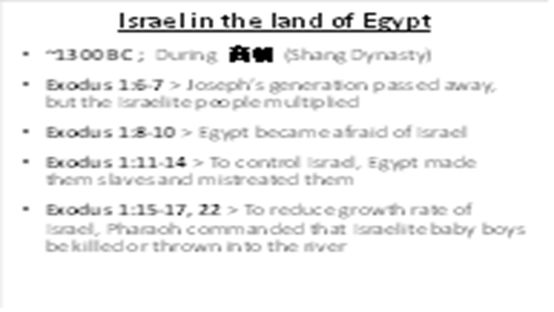 | But all of the Egyptian Pharaohs did not appreciate the Israelites. During the Shang Dynasty (Shāng cháo ~1300BC), we see that Joseph and his generation died, but the Israelite population grew very fast (Exodus 1:6-10). A new leader came into power over Egypt who did not show kindness to Joseph’s relatives. He was afraid that the Israelites may fight against the Egyptians if war broke out (Exodus 1:11-14). They then forced the Israelites to become slaves to try and control their population. They made them work hard and treated them badly.  But Israel kept growing. So Pharaoh ordered all of the Hebrew midwives to kill any male child born (Exodus 1:15-17), but the midwives feared God more than Pharaoh, and they did not do what Pharaoh said. So the people of Israel kept increasing, and God blessed the midwives. Once Pharaoh realized that this was not working, he ordered all male children born to be thrown into the Nile River (vs.22).
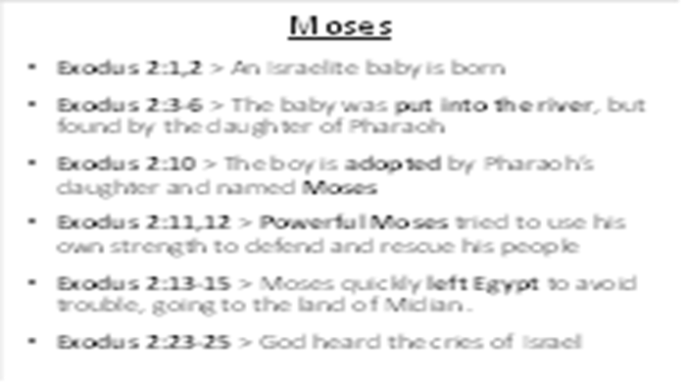 | At this time an Israelite woman gave birth to a boy (Exodus 2:1,2) and hid him for 3 months. When she did not think she could hide him any longer, she put him in a basket and placed the basket among the reeds on the Nile River. Pharaoh’s daughter went to the river and found the baby. She took him in as her own son and named him Moses (Exodus 2:10). What are some of the advantages Moses would have living in Pharaoh’s household?  Even though he was raised as an Egyptian prince, Moses still understood that He was a child of Israel. One day, while watching an Egyptian beating an Israelite (Exodus 2:11-15), he decided to try and solve the problem with his own efforts. As a result of his actions, he fled from Egypt. What did Moses do to try to help his people? Did the people appreciate his help? Could one human release all the people of Israel from Egypt? Of course not.  In Exodus 2:23-25, we see that the king of Egypt died. The Israelites were still in slavery, and they cried to God for help. God heard their cries, and He honored His promises to Abraham, Isaac, and Jacob.
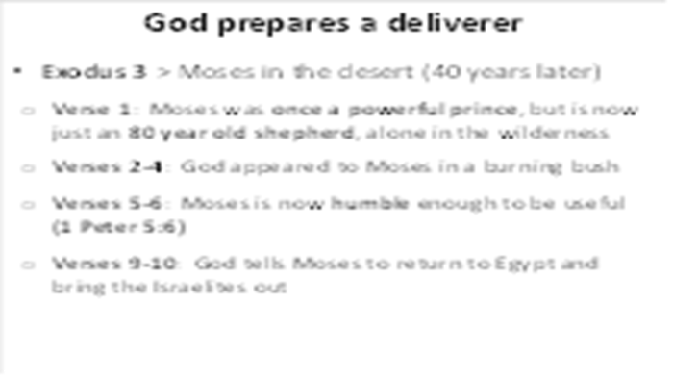 | In Exodus 3:1, we see that Moses had a “major career change” from exalted Prince of Egypt. After spending 40 years in the world’s best universities and most elegant palace, he moved down to the lowest position of the day, spending the next 40 years as a lowly shepherd taking care of someone else's’ sheep on the edge of the desert.  Now that Moses has been humbled, God meets with him on a special mountain. He takes him through similar steps to those we go through when we become believers in Christ:  Step 1 (v.2) – enlightenment: God appeared to Moses in a flame of fire from within the bush.  Step 2 (v.3) – investigation: Moses saw the bush on fire but noticed that it was not burning up so he went to see it.  Step 3 (v.4) – calling: When the LORD saw that he had gone over to look, God called to him by name from within the bush.  Step 4 (v.5,6) – humility: God told him that He is the God of Abraham, Isaac and Jacob. At this, Moses hid his face because he was afraid to look at God.  God then told Moses that He was concerned about the children of Israel and planned to lead them out of slavery in Egypt to a new land (v.9,10).
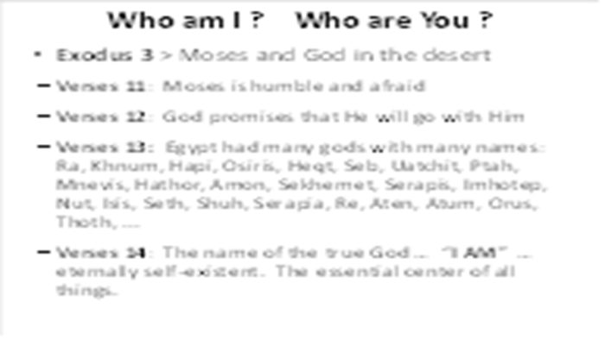 | Moses told God that he did not feel like he was the right man for the job (v.11). God told Moses that He would be with him (v.12) and He told him that when he had brought the people out of Egypt, they would worship God on that very mountain.  Moses had been educated in Egyptian schools, learning about many Egyptian gods like “Ra” the sun god, “Geb” the earth god, “Isis” the goddess of magic, “Heket” the goddess of frogs, “Hapi” the god of the Nile, etc. So to him, it seemed important to know the name of God so that the people would believe he had truly been sent on this mission (Exodus 3:13).  In response, God says something very important about Himself in verse 14. He is not like manmade gods, invented in the human imagination. He is entirely different – He is “I AM” – the only One who is self-existent, without beginning or end. And soon, He will make it very clear to the Egyptians, the Israelis, and the entire world that He is the One true God.
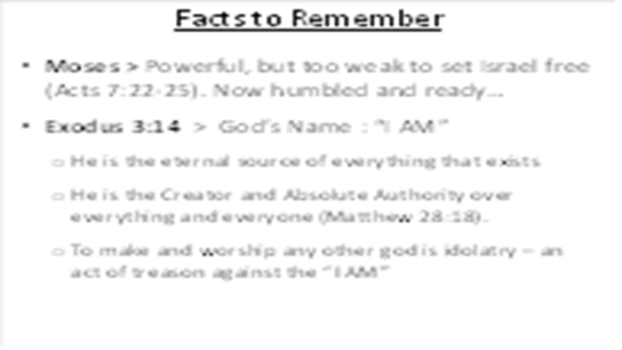 | Always remember that God has absolute authority over everything: every star and galaxy (Isaiah 40:26), every nation and people group (Proverbs 21:1), every storm (Mark 4:39), every plant and worm (Jonah 4:6-8), every virus and bacterium, etc.  “If there is one single molecule in this universe running around loose, totally free of God’s sovereignty, then we have no guarantee that a single promise of God will ever be fulfilled.” ― (R.C. Sproul, Chosen By God: Know God's Perfect Plan for His Glory and His Children)
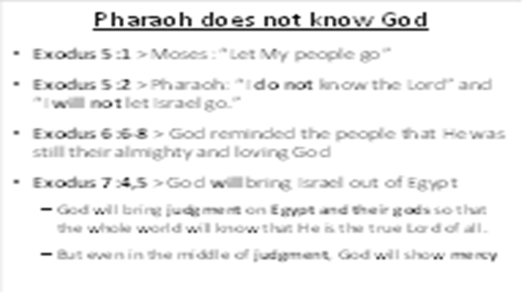 | Before Moses began his journey to Egypt, God made it clear that Moses should expect Pharaoh to resist (4:19,20). And as God had said, Pharaoh was stubborn and proud (Exodus 5:1,2). Based on his answer, Pharaoh sounds like he did not know God now and didn’t expect to know Him in the future. He was the king, he gave the commands, and he was satisfied with worshiping the gods of Egypt and the physical things that they represented.  Although the Israelites living in Egypt had heard about the Lord and what He had done for Abraham, Isaac, Jacob, and Joseph, they had never experienced His power personally. Now the Lord was going to use this evil Pharaoh and his rebellion to display His power and wisdom to the Israelites so that they would know that He was still the almighty and caring God of Israel (Exodus 6:7).  He also planned to show the Egyptians that He alone is the true and living God with power over the whole earth (Exodus 7:5). The false gods they trusted and worshipped were unable to protect them from the true and living God of all. But remember this: even in the midst of God’s judgment, He has a merciful plan. He knows that all people, Israelite or Egyptian, are never satisfied with weak and powerless gods, including money, fame, and power. Keep that in mind – I’ll show you something special about that later.
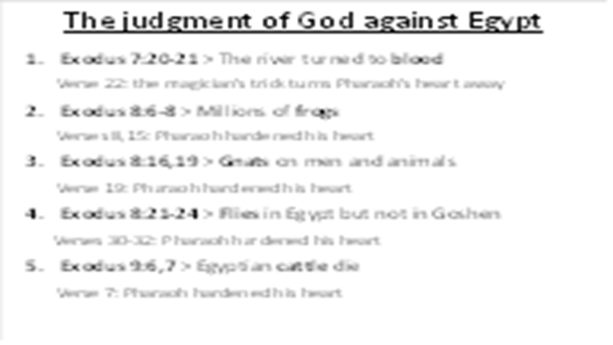 | Step by step, God begins to bring judgment to all of the things that the Egyptians worshiped, starting by turning the Nile river into blood (Exodus 7:20,21). But Pharaoh’s magicians did a trick, changing the color of some water (v.22), helping Pharaoh to ignore the judgment of God (harden his heart). Notice this – whenever God seeks to reach out to people, there is a liar (Satan) who will produce a counterfeit (fake) to try and lead people away.  The next week, God brought millions of frogs up into everyone’s houses (Exodus 8:6-8). Even though the magicians did their own trick, Pharaoh asked for mercy. But when the pain was over, Pharaoh hardened his heart again (vs.15).  Next, God turned the dust of the earth into gnats (vs.16). Don’t just think that “the hand of God” works on the scale of planets and stars – the “finger of God” (vs. 19) also works on the microscopic level. But Pharaoh has refused to believe in spite of the evidence. Next, God does something even more amazing: He sends swarms of flies into Egypt, but keeps them out of the province of Goshen (vs.22-24). But once again, Pharaoh hardens his heart when the flies are gone (vs. 30-32).  Now, the severity of the plagues rises. God brings a sickness among the Egyptian cattle but spares the Israelite ones (Exodus 9:6,7). But in spite of this great loss, the stubborn Pharaoh continues to harden his heart.
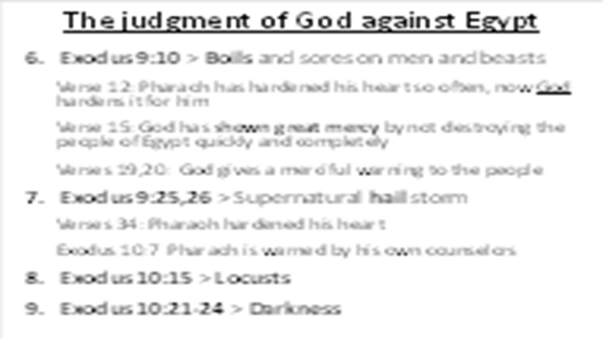 | So the next plague comes upon the people, bringing festering boils upon their bodies (vs.10). Pharaoh has hardened his own heart so many times, that now, God hardens it for him (vs. 12) Here is a lesson to learn – when someone continues to resist God, eventually, their heart becomes too hard to change, regardless of the amount of evidence.  Perhaps it seems like God is being too hard on Pharaoh and the Egyptians. But remember – God could easily have just killed them all instantly (vs.15). Actually, God is merciful, giving people time to listen to Him and follow (v.19,20). And those who ignore the word of God suffer devastation because of the supernatural hailstorm (vs.25,26). But Pharaoh continues to ignore God and his own counselors (Exodus 10:7), experiencing two more plagues: locusts (v.15) and darkness (vs.21,22).
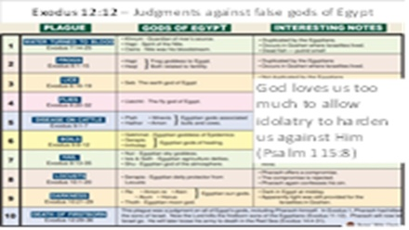 | In Exodus 12:12, God clarified why He chose the plagues that He did: “on all the gods of Egypt I will execute judgments: I am the LORD.” Although we won’t spend much time on this chart, we can see which specific gods each plague was judging.  When we worship a god of our own creation, Psalm 115:8 says that “Those who make them become like them; so do all who trust in them.” Since the creator is greater than his creation, a man who creates a “god” is actually superior to that god, showing that idolatry is actually self-worship: men choose to take the place of god (high treason).
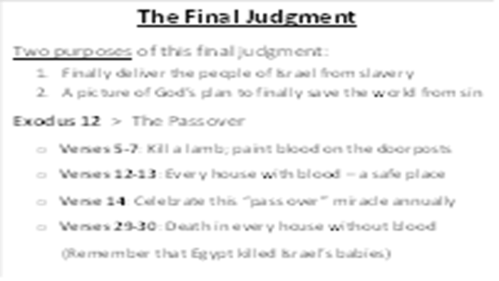 | Although the Lord already sent 9 terrible plagues on the rebellious Egyptians, the king of Egypt still refused to obey the Lord and refused to let the Israelites go free. God was about to send the final plague, one that would free the people from slavery, but one that would also have a far greater significance in the long-term history of God’s saving plan for the world.  In Exodus 12:5-7 we see that God told the people to take a sheep or goat, one year old with no defects. All of the Israelites were supposed to kill their animal at twilight and put some of the blood on the sides and tops of the door-frames of the houses. That night, if anyone’s house did not have the blood of the lamb painted on the door, someone inside would die (vs.12,13). Note that God was bringing judgment on all of the false gods of Egypt. But if the blood of the lamb was on the door, death would “pass over” that house. Notice also that God commanded the people to celebrate this “Passover Feast” every year (vs.14), remembering what He had done to save them from slavery by the sacrifice of a lamb.  This event contains a very important salvation clue: everyone deserved to die, even Moses, the murderer. There was only one way to escape death: the blood of a lamb on the wooden doorposts.
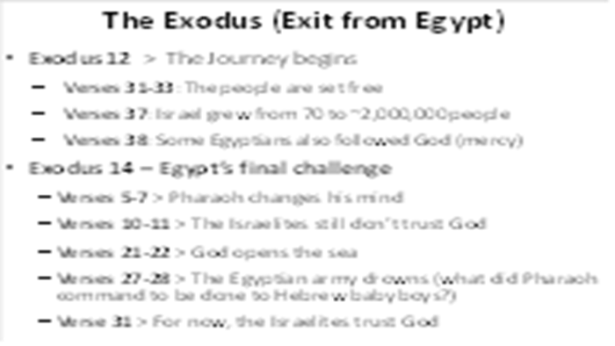 | And God did exactly as He promised, prompting Pharaoh to let the people go (vs. 31-33).  When the Israelites first went to Egypt, there were only 70 of them. Now there are probably about 2 million Israelites. Also notice this: some believing Egyptians joined the Israelites as they followed God (vs.38). As I said earlier, God is calling all people to Himself, regardless of their nationality.  God loved the Israelites and took care of them, guiding their steps all the way (Exodus 13:21,22). Sometimes, the Israelites didn’t like where God was taking them. But God makes no mistakes, using each step of their path to teach them (and us) some important truths.  You would think that, by now, Pharaoh would have learned his lesson. But God still has another purpose for him. Pharaoh gathers his most powerful military machines and pursues the Israelites (Exodus 14:5-7). As the Israelite people see the mighty army approaching, it is clear that they still don’t trust God (vs.10,11). But Moses tells them to be quiet and still – watch what God does next (vs. 13,14).  The Israelites could not save themselves. The sea was in front of them, mountains were around them, and their enemies were behind them. The Israelites had seen all the great and mighty things the Lord had done in Egypt, but they still did not trust in the Lord. Even though the Israelites sinned and did not trust in the Lord, He was merciful and planned to deliver them. It is the same with us. We cannot make things right between us and God by things we do. Only God can save us from everlasting punishment.  God told Moses to stretch out his rod over the water. The water separated (vs.21-22) so there was dry ground, and the children of Israel walked through the sea. When the Egyptians saw this, they started to cross the sea on the path of dry ground (Exodus 14:26-29). This was a bad decision on their part and reminds us of the Egyptian command to throw all of the Hebrew boy babies into the river. Once again, Moses (and the people) are safely taken out of the water by the grace of God (vs.29-31), leading them to fear the Lord and put their trust in Him. At least, for a while…
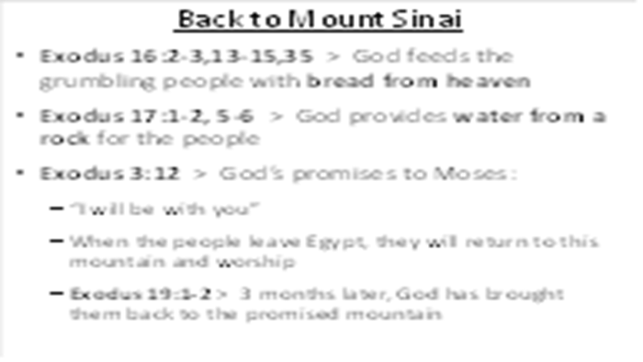 | A few quick true stories along the way:  Exodus 16:2-3,13-15,35 > God feeds the grumbling people with bread from heaven  Exodus 17:1-2, 5-6 > God provides water from a rock for the people  Exodus 3:12 > Remember God’s promise to Moses: “I will be with you.” When the people leave Egypt, they will return to this mountain and worship  In Exodus 19:1-2, we see that 3 months had passed since the Israelites left Egypt. God led them, by a pillar of cloud and fire, to the Desert of Sinai and told them to camp in front of Mount Sinai, the place where God originally met with Moses. God fulfilled his promise to Moses, but notice that confirmation sometimes comes later in our journey than we expect.
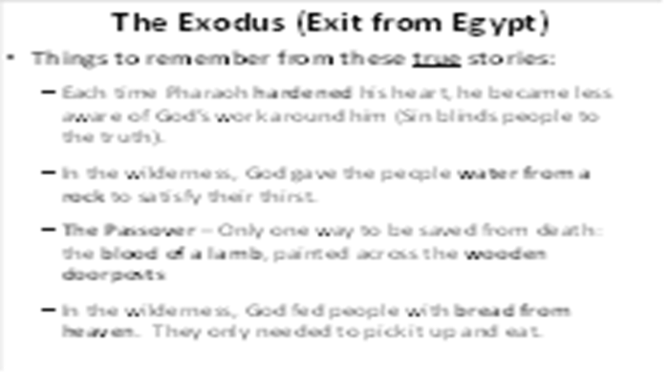 | Things to remember from these true stories:  * Each time Pharaoh hardened his heart, he became less aware of God’s work around him (Sin blinds people to the truth).  * In the wilderness, God gave the people water from a rock to satisfy their thirst.  * The Passover – Only one way to be saved from death: the blood of a lamb, painted across the wooden doorposts  * In the wilderness, God fed people with bread from heaven. They only needed to pick it up and eat.  Remember these important “clues.” They are not just random stories of people wandering in the wilderness – they each point to an important truth about how God will ultimately save all of humanity.
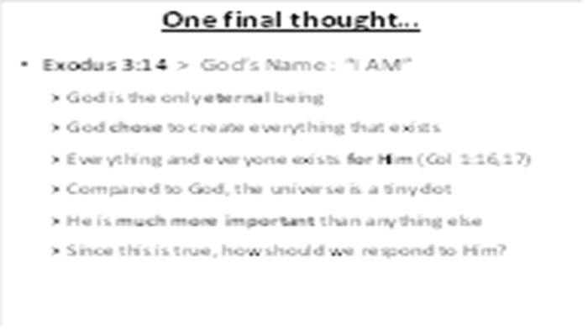 | As we finish our lesson tonight, I want to take you back to Exodus 3:14. Take a moment to consider the fact that God Is. He always has been. He is the source of everything else. Next to Him, the universe is a tiny, temporary speck. He is of ultimate importance. Every other thing that absorbs our attention is minor compared to Him. Since this is true, how should we respond to Him?
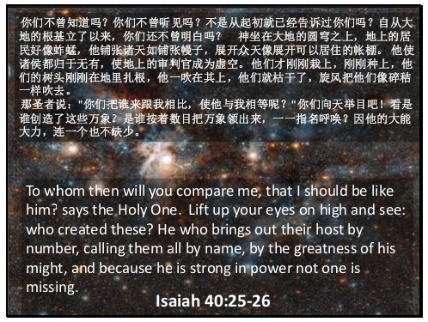 | We should end each lesson by reminding listeners about the glory and greatness of God. Remember – He is at the center of this story!  Colossians 1:16,17 “For by Him [Jesus] all things were created, in heaven and on earth, visible and invisible, whether thrones or dominions or rulers or authorities—all things were created through Him and for Him. And He is before all things, and in Him all things hold together.”

