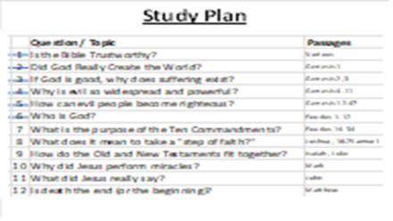
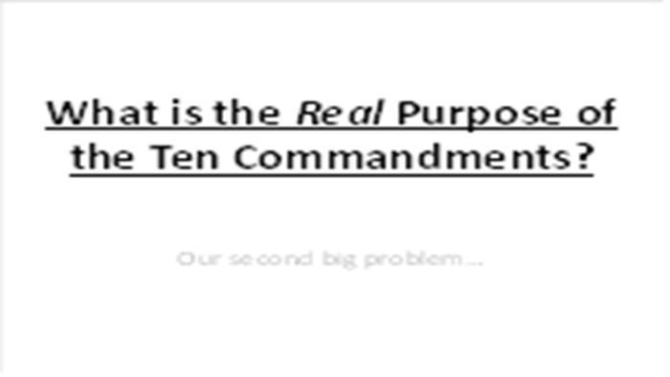 | We’ve talked a lot about the first big problem of all humanity – sin leads to death. Tonight, we’ll discover the second big problem that all people face.
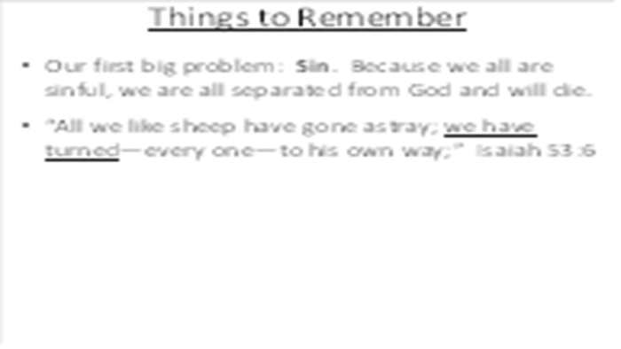 | As we’ve said before, sin is much deeper than the wrong things that we do, it is who we are, woven into our DNA. When we act as though God does not exist, we go our own way and seek our own glory. Basically, we take the God of the Universe off His throne and try to take His place – high treason!
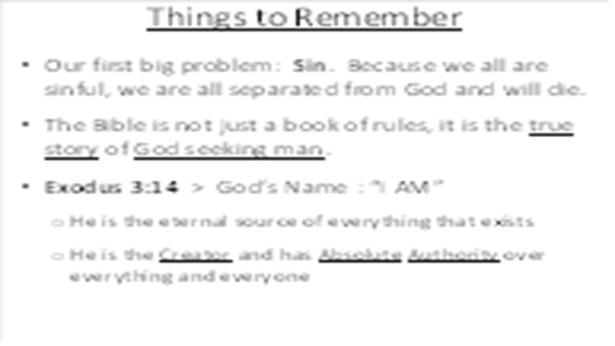 | Our problem is much deeper than good or bad behavior. Since we cannot save ourselves, God gave us His word to bring us back to Him.  As the great “I AM,” God is the only self-existent, eternal being, He is the source of everything that exists: every physical or spiritual thing, every truth of logic or philosophy, every law that governs the universe.  Always remember that God has absolute authority over everything: every star and galaxy (Isaiah 40:26), every nation and people group (Proverbs 21:1), every storm (Mark 4:39), every plant and worm (Jonah 4:6-8), every virus and bacterium, etc.  “If there is one single molecule in this universe running around loose, totally free of God’s sovereignty, then we have no guarantee that a single promise of God will ever be fulfilled.” ― (R.C. Sproul, Chosen By God: Know God's Perfect Plan for His Glory and His Children)
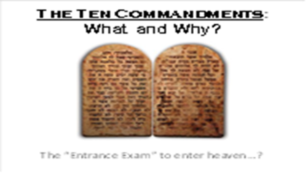 | If God were to give each of us an “entrance exam” to enter heaven, how would we do?  Imagine for a minute that the 10 commandments were like the SAT or GaoKao…
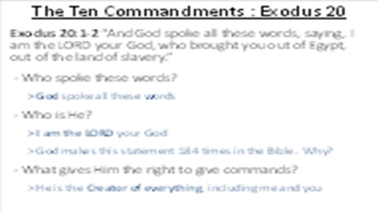 | Before God gives the 10 commandments to people, He starts by proclaiming His authority over them (and all mankind) in Exodus 20:1-2.  These are not just the words of Moses – they are the words from God!  God constantly reminds people that “I am the Lord” (184 times). People quickly forget and worship other things (or themselves).  He has ultimate wisdom and power over everything in the universe, hence, the first commandment…
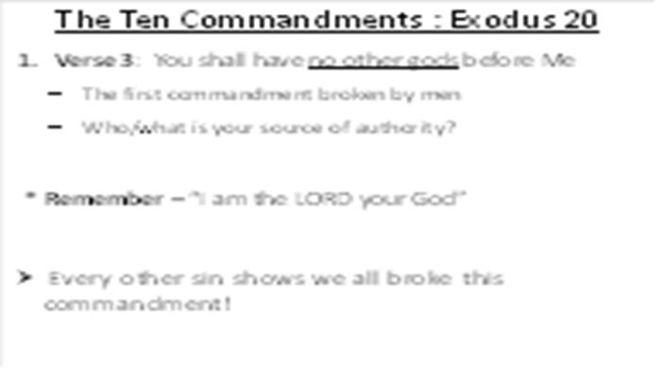 | The First Commandment – God begins with the first commandment broken by men. In the garden, they abandoned Him and sought to be their own God. Ever since that day, we have all tried to take the place of God, determining our own purpose for life, defining our own rules of right/wrong, and trying to save ourselves by fulfilling our own dreams. Is there anyone who has kept this command, always recognizing that the true God is Lord of all (including us)?  Our #1 offense: turning our back on God and going our own way (trying to become our own god).
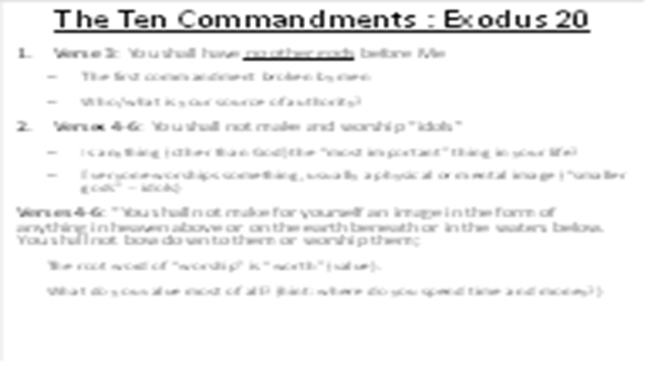 | The Second Commandment - The word “worship” comes from two words: “worth” and “ship.” We worship something when we assign a very high level of “worth” to it. Here is a fact of life: we all worship something – we all worship “smaller gods.” Here is the test – is there anything or anyone that is more important to me than the true God? Have I taken “good” things like career, material possessions, and family, and turned them into “ultimate” things, seeking significance, security, safety and fulfillment in them?  One way to determine the most important thing in your life is to “follow the money and the time.” If you were to look at your calendar and your bank account, what would you learn about “worship”?
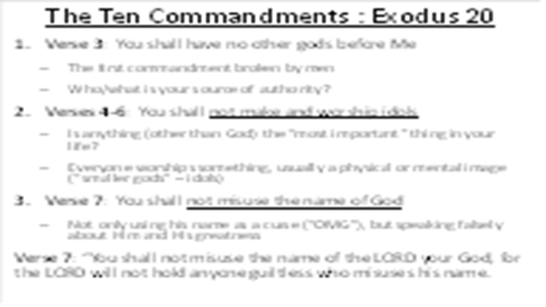 | The Third Commandment - Although this includes saying the name of God as a curse (e.g. “OMG”), it goes much further. God is our creator and provider, and when we complain against Him, we are speaking falsely about His great name. Conversely, when we do not speak His name with thanksgiving (Colossians 3:17), we break this command as well (even in our heart).  Remember how the Israelites broke this commandment in the wilderness, saying the God had brought them out of Egypt to kill them (Exodus 14:11, 16:3, 17:3)
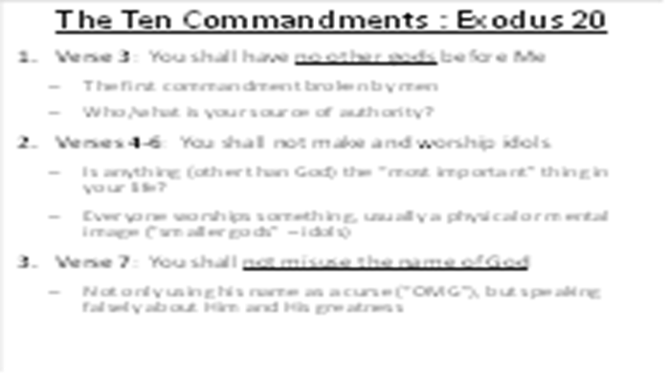 | So, here are the first three commandments out of ten – how are you doing so far? Have you kept them perfectly?
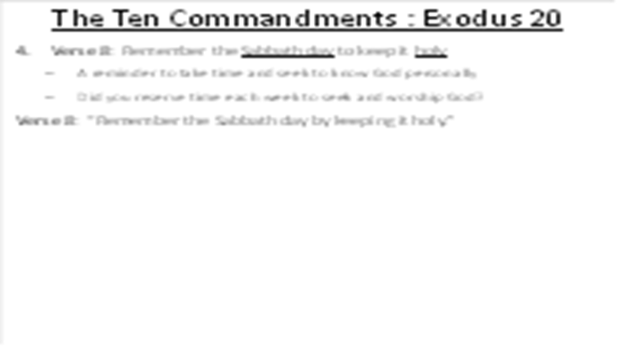 | The Fourth Commandment - In our busy world, do we regularly set aside a significant amount of time to regularly seek and worship God? God made us and knows what’s best, so he gave us this structure for blessing and freedom. Yet, we spend our time working hard and burning out in pursuit of things that quickly fade away.  God didn’t just give the people a list of external rules to obey – He wanted them to know and love Him, so He gave them the Sabbath to rest, reflect, and grow in their relationship with Him. Sadly, the people reduced the commandments (including the Sabbath) to heartless, physical rules. God often rebukes the people for worshiping Him with their words, but their hearts are far from Him. (Isaiah 29:13)
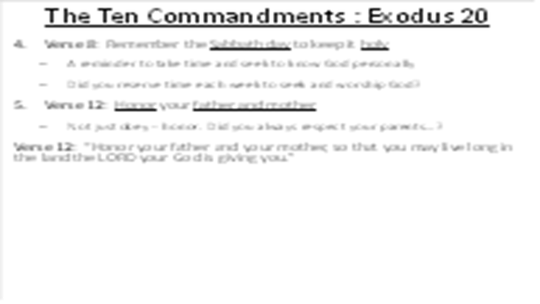 | The first four commandments focus especially on our relationship with God. The second six commandments guide our relationship with people (although we always offend God when we ignore any of His commands).  The Fifth Commandment - Not just obey parents – honor them. Have you ever debated with your parents? Have you always protected their honor or have you complained against them behind their back?
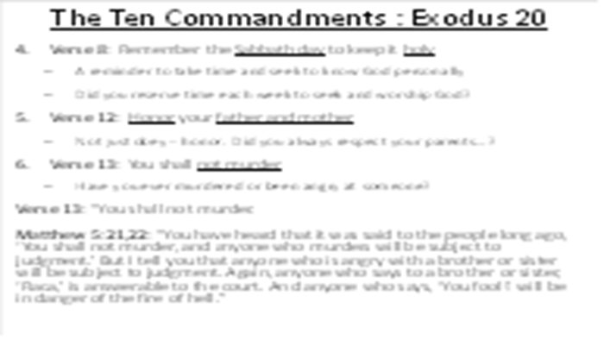 | The Sixth Commandment - Maybe Moses shook when he heard this one (he was a murderer). You might be thinking, “Finally, here is one that I haven’t broken!” But Jesus reminds us of something important – God knows and cares about what is in your heart. It’s not just our actions: everyone who has ever been angry has broken this command (Matthew 5:22).
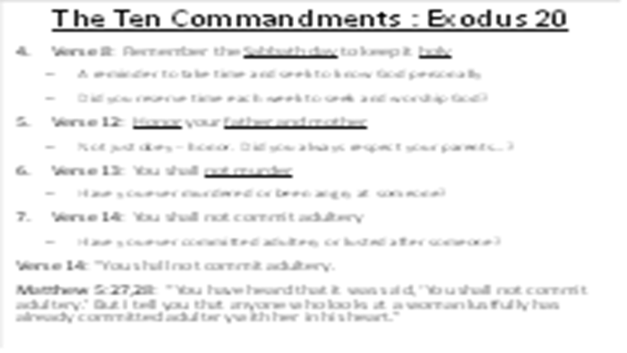 | The Seventh Commandment - God created sex for a wonderful purpose (in the context of marriage). It is a holy and beautiful thing and is designed as a picture of our faithful relationship with Him. But we have turned it into an unholy way to satisfy our physical and mental lust (Matthew 5:28). You can see why God often speaks about adultery and idolatry in the same context.
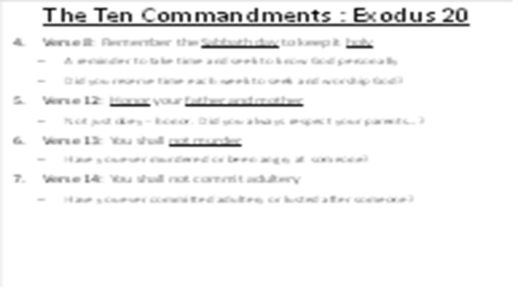 | We’ve now viewed seven of God’s ten commandments. If you’re like most people, you’re beginning to feel a bit concerned about standing before God, the Holy Judge.
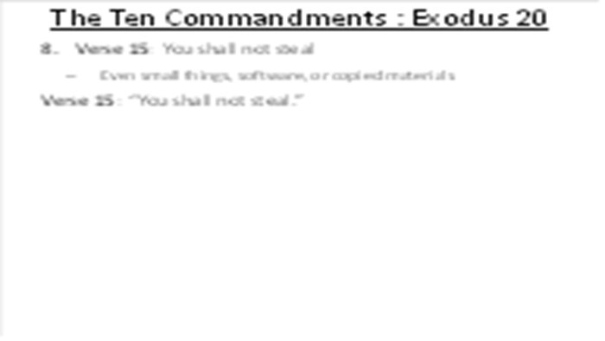 | The Eighth Commandment - We are all thieves, starting from when we were small children taking toys from other children. We grow up and take bigger things, physical and virtual. We download pirated software and music, we steal time from others, and we copy the work of others and claim credit for ourselves. Why do we steal? Because we do not trust and believe God’s promise that He will provide for our needs (like the Israelites).
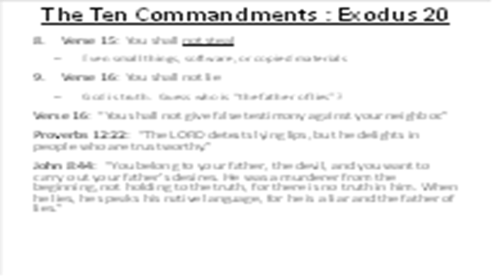 | The Ninth Commandment - God hates lying (Revelation 22:15). Whenever we lie, it reminds us who we are – children of “the father of lies” – Satan (John 8:44).  Why do we lie? Because we think that we must lie to get what we think we need from others or to escape a difficult situation. Once again, it demonstrates that if we choose to be our own god, we also make up our own rules.  We also know that our small lies eventually grow up to be big lies. Close relationships (like marriage) require trust, and trust requires honesty. Perhaps it isn’t a surprise that close relationships are becoming rare…
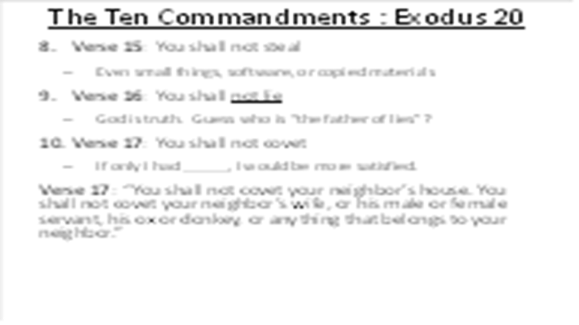 | The Tenth Commandment - Have you ever thought something like this: “If only I had ______, I would be more successful and satisfied.” When we look at someone else* and strongly desire what they have, we are basically telling God that we are not satisfied with what He has given to us. We are basically showing that we do not trust Him. This 10th commandment exposes the fruit of our failure to obey the 1st one. Our biggest problem is not only our bad behavior – it is our bad belief.  * Beware the “comparison trap” – it always leads to coveting, criticism, or self-exaltation – revealing the true nature of our sinful heart.
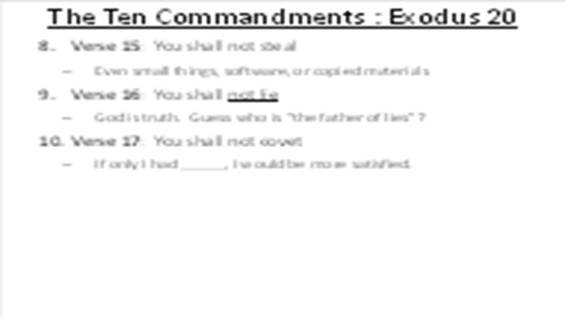 | So there it is – ten commandments from God. We often refer to this as God’s moral law.
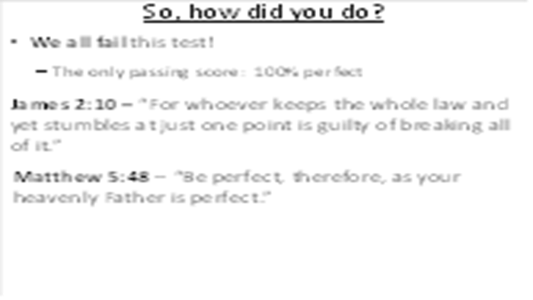 | So, you just took God’s entrance exam for heaven. How did you do? By the way, the “passing score” is very high – 100% (Matthew 5:48). If you miss just one, you fail (James 2:10).  When we compare ourselves with others, we often think that we aren’t too bad. In fact, when people are asked if they consider themselves to be more moral, ethical, or fair than the average person, more than 60% to over 80% say yes. (This tendency—part of the psychological "better-than-average" effect—is even stronger for moral traits than for intelligence or physical skills).
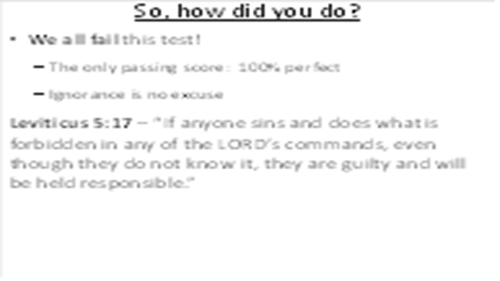 | When we compare with others, we deceive ourselves into believing that we are better than others, But this test asks a more important question: how do I measure up against God’s standards of moral goodness?  And by the way, ignorance is no excuse (Leviticus 5:17).
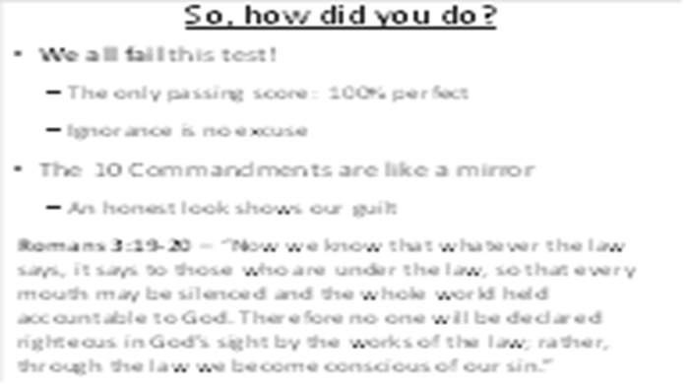 | If we are honest with ourselves, the Ten Commandments are like a mirror for our soul (James 1:23-24) When we look at them, they clearly show us our sin. Some people assume that, in order to be a good person, we should keep the Ten Commandments. But the Bible provides a more important reason for the Ten Commandments:  Romans 3:19,20 – The “Ten Commandments” (“the law”) we not given to help bad sinners be better sinners. It was given to show us that, before a perfectly holy God, we all stand guilty without defense.
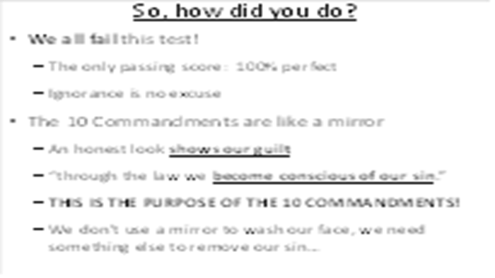 | The Ten Commandments were not given to improve the behavior of sinners – they were given to make us conscious of our sin. Like a wise medical doctor explaining the danger of stage 4 cancer to his patient, the Ten Commandments show us that are desperately in need of radical surgery in order to survive!  Every person is infected with the “cancer of sin.” We will not get better by trying to ignore it. We need someone to save us.
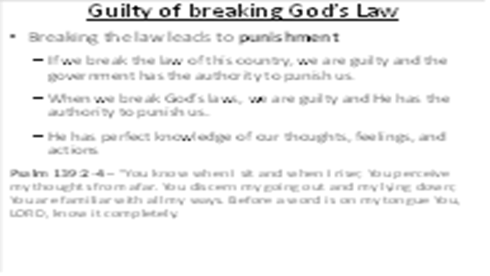 | When we break the laws of our country, the government has the authority to punish us. They don’t ask us if we like the law or approve of it – we are not given that privilege. Similarly, when we break the laws of God, He has the authority to punish us. And remember, He knows everything perfectly (Psalm 139:2-4).
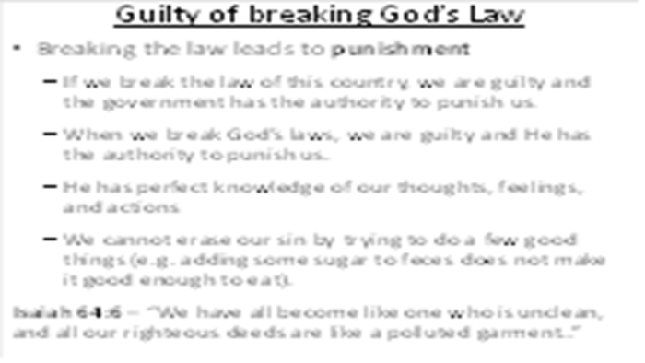 | Sin is the word used by the Bible for breaking the laws of God. As you can see from these Ten Commandments, we can sin when we do the things that God tells us to avoid, or when we fail to do the things that He requires. Here is a very big problem for all of us: God has clearly spelled out His law, we have clearly broken His law, and we all must suffer the punishment for our sin.  The Bible does not say we can “balance” our sin with good works any more than we can add some sugar to a jar of feces and make it edible. Every good thing we try to do gets contaminated by the sin in our lives. Even the “good things” are unacceptable to God.
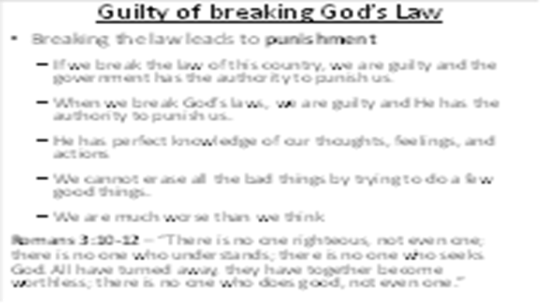 | At the beginning of these lessons, we said that we would be studying the foundational issues and main themes of the Bible. This is one of the wonderful things about the Bible: these main themes are consistent all the way through the Bible. The fact that God is holy and righteous and demands a high price for sin (death) is one of the foundational themes.
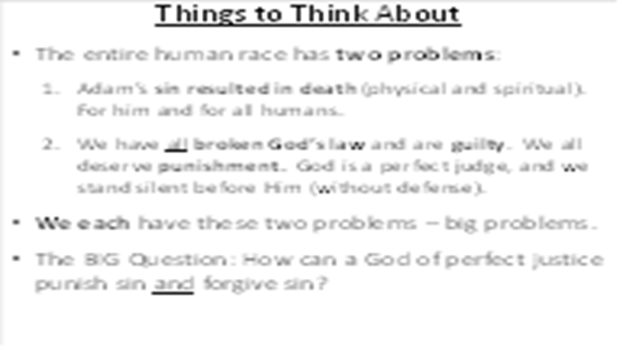 | By now, you should have noticed that the entire human race is in trouble. We have two kinds of trouble:  1) Adam’s sin resulted in death. Death for Adam and death for all humans.  2) We have all broken the Ten Commandments and are guilty before God, deserving severe punishment.  We have a problem – a big problem. Is there any hope for humanity? Is there any hope for you? When we read the Bible, we certainly see that there is “bad news” for all people here! And since God is a God of perfect justice, how could He possibly forgive such sinful people? This week, think about these two big problems we each face: death and judgment.
