
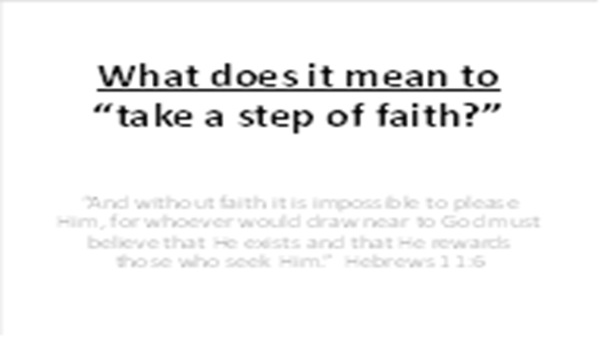 | All around us, creation demonstrates the existence and power of God. You don’t have to look too far to see that God has created a very complex and well-balanced universe, that He loves beauty and diversity, and that He has graciously provided everything needed to sustain the life of all His creatures (including us). And He has given us more than the “general revelation” of creation – He has also provided the “special revelation” of the Bible. In the Bible, God directly communicates many detailed facts about His plan for history and truths about Himself.  God does not require people to close their eyes and blindly come to Him. He gives us so much evidence about His existence and power. But even with all of this evidence, He also requires that we come to Him in faith, trusting Him and His promises. The Bible is filled with facts about God and His plan. But it also speaks about the importance of faith….
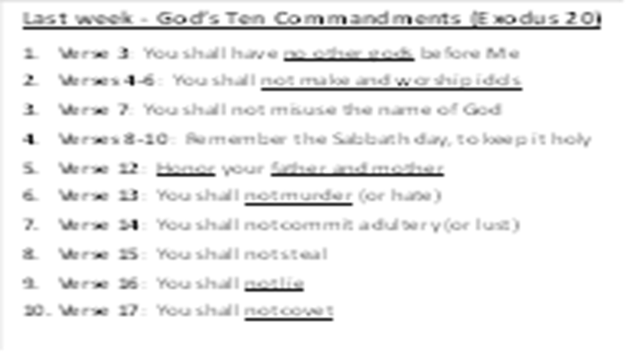 | In our last lesson, we reviewed the Law of God – the 10 Commandments. It is important to remember that we have all broken God’s law and stand before Him guilty and responsible. We also saw the people of Israel – even though they said they would trust and obey God, they backed away in fear as He exposed their sin.
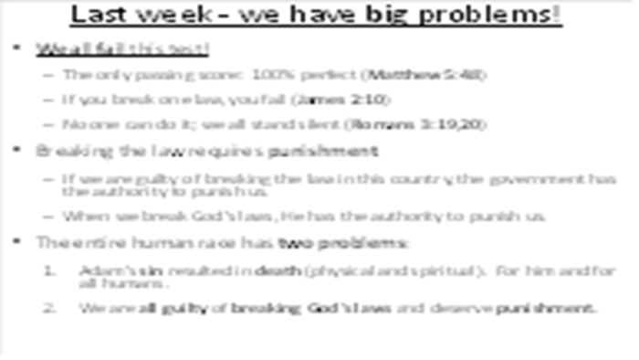 | While some people falsely believe that they can please God by keeping all of the 10 commandments all of the time, the Bible makes it very clear – no human being has the power to please God by their own good works. As we saw, the actual purpose of the 10 commandments is to show that we all stand guilty before God. Every person has two very big problems: sin leads to death and we are all guilty of breaking God’s law. This is the “bad news” of the Bible.  After God gave the 10 commandments to the people of Israel, they quickly demonstrated their sinfulness by breaking them (Exodus 32:1-9). He punished them, but then He forgave them, consistent with His revealed character (Exodus 34:6,7).  God then sent them on their journey to the “Promised Land,” The place where He planned to settle them and help them grow into a great nation. But when they arrived, they failed their biggest “faith test”…
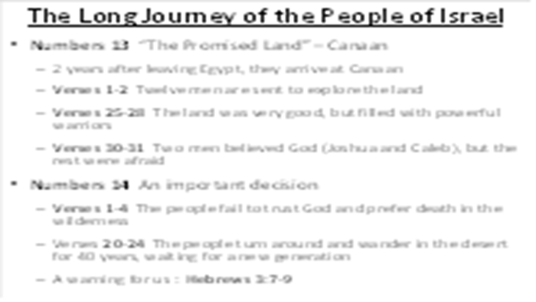 | 24 months after leaving Egypt, the people finally reach the “Promised Land.” In Numbers 13, we see that God told Moses to send out one man from each tribe of Israel to explore the land of Canaan. After 40 days (Numbers 13:25-28), the spies returned with fruit from the land. They told the Israelites that the land was good but that the people and the cities on the land were great and powerful. Ten of the men said that it was not possible to take the land. But two of the men (Joshua and Caleb) said that it did not matter that the people and cities were great and powerful because God was on their side (verse 30).  For two years, these people had seen God’s mighty power first-hand. And now, He is giving them the opportunity to follow Him into this good land. Just like Adam in the garden, God gave them a choice: trust Me and follow Me, or turn away and trust yourself. And just like Adam, the people turned away from the God who is mightier than any army on the planet (Numbers 14:1-4).  God could’ve instantly killed the people for their disobedience, but He forgave them. He gave them what they asked for in verse 2 – He told them to turn around and go back into the desert – and die there (Numbers 14:20-24). So, for the next 40 years, they wandered around as a new generation grew up, one that would trust God and follow Him into the Promised Land.  This was a very sad decision on their part, a decision that becomes an example for us to avoid (Hebrews 3:7-9). For the next 40 years, they wandered around and died in the desert until a new generation grew up to take their place. Many important events happened during their journey, but we only have time to look at one more before they enter the Promised Land.
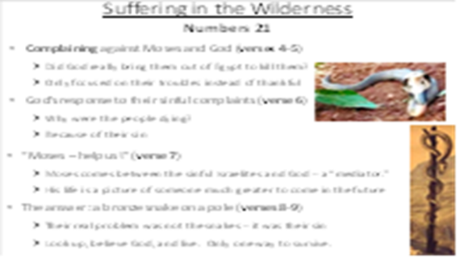 | Read Numbers 21:4,5. Once again, we find the Israelites angry at Moses and God. Even though they awoke every morning to find His bread on the ground, they were no longer thankful and spent most of their time complaining about their circumstances. Does this ever happen to you? You know that you should be grateful to God, but instead, you look at your troubles – and you complain.  Because of their complaints, God gave them something else to think about: poisonous snakes (v.6). Think about this carefully – why were the people dying? They were not dying because of the snake bites, they were dying because of their sin – lying about God and His goodness. The snake bite was just the way that death came to them. Like in the garden of Eden, the root cause of death is sin.  Now that they began to experience the immediate result of their sin, they recognized their guilt and need for deliverance. They asked Moses to plead with God to take away the snakes (v.7), so Moses prayed for them. Something to notice here: throughout their journey, Moses would come between God and the sinful Israelites. He was a “mediator”: delaying the judgment of God while delivering messages to the people. He is a picture of someone much greater to come in the future.  Remember, the real cause of their death was not the snakes – the real cause of death was their sin. So God didn’t take away the snakes – He did something unexpected. God told Moses to make a bronze snake and put it up on a tall pole (v.8,9). And whenever anyone was bitten by a real snake, if he looked up at the bronze snake on the pole and believed God’s promise of healing, he would live. It seemed strange that God would use the symbol of death, a snake on the pole, to bring about life. But it worked. They didn’t need to go to the doctor. Just look up and trust God.
 | And for centuries, the people of Israel probably had no idea what was so special about this story. They read about it and talked about it but didn’t know why God would tell Moses to make a snake, lift if up on a pole, and tell dying people to look up and believe. But when we read the New Testament in a few weeks, you will discover the true meaning.  By the way, ever since that time, the snake on the pole has become a global symbol for medical services and healing all around the world:
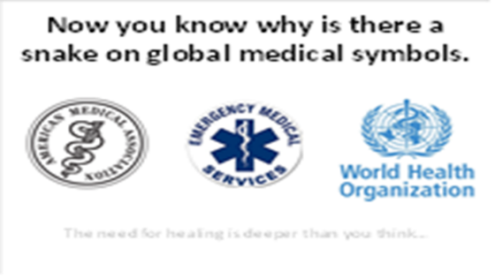 | Wherever you go, you will see a snake on the pole to represent healing and medical services. And you are one of the few people who know the true story about the origin of this symbol. But soon, you will see that it is much more than just a symbol of physical healing…
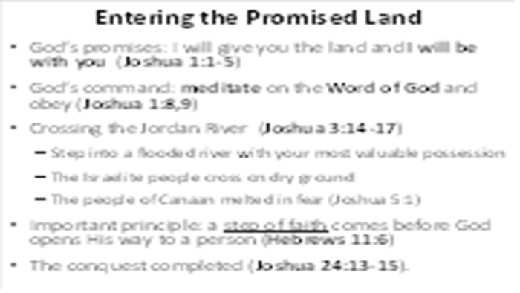 | The people continued to journey for many years, and finally they prepared to enter the land for a second time (Joshua 1:1,2). Joshua now replaced Moses as the leader of the people, and God gave him an important command and a wonderful promise (verses 8,9): meditate on the Word of God, do what it says, be strong and courageous, and I will be with you wherever you go.  God fulfils His promise to Joshua three days later. He commands the priests to carry the ark of the covenant, the most precious possession of the nation, and step into the Jordan River (Joshua 3:14-17). When their feet enter the water, the river splits in two, opening up and allowing the entire nation to cross on dry ground.  This miracle strengthened the faith of the people and melted the hearts of the kings of the land that were about to be defeated (Joshua 5:1). But notice an important principle here: the river didn’t split until the priests stepped into the water. This is a model of faith in the Bible: when we take a step of faith toward God, He opens up the way toward Himself. Even though He does the work, He requires that we must first take a step of faith (Hebrews 11:6).
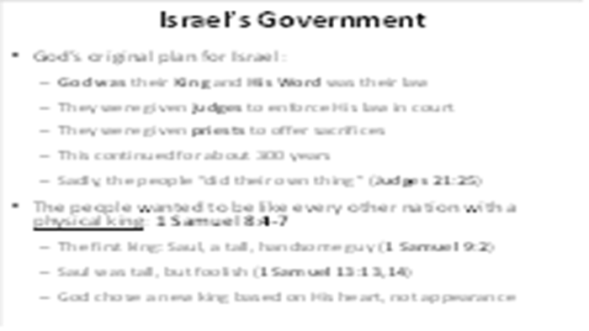 | Just as He promised, God led the Israelites into the Promised Land, conquering the people who stood against them. Each of the twelve tribes received a portion of the land for their own possession. God then established a unique governmental system for them:  God was their King and His law was the law of the land  God appointed a system of judges to help the people follow the law  God appointed a group of priests to offer sacrifices for their sins  After about 300 years, the people decided that they didn’t like God’s system. Instead, they demanded to have a physical king, just like the nations around them (1 Samuel 8:4-7). Their first king was a tall handsome guy named Saul (1 Samuel 9:2). But even though he was physically impressive, he disobeyed God and struggled to lead the nation (1 Samuel 14:13,14). During this time, God selected a new king, “a man after His own heart.” And that king is about to enter the scene.
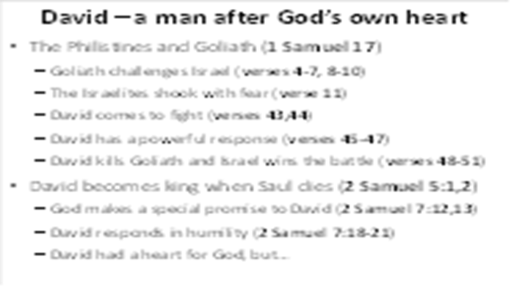 | As we turn to 1 Samuel 17, we find Saul and his army facing the powerful Philistines. Not only did the Philistines have superior weapons, they had a huge champion named Goliath, about 3 meters tall. Every day, he would challenge one of the Israelites to a fight, leaving Saul and the whole army of Israel shaking with fear (verses 10,11). One day, a young man named David steps out of the pack to fight Goliath, prompting Goliath to joke and curse (verses 43,44). But David has a powerful response (verses 45-47), trusting in God and seeking His glory. David’s words come true as he kills Goliath and removes his head (verses 48-51), rallying the army of Israel to conquer the Philistines.  When Saul dies, David becomes the second king of Israel (2 Samuel 5). God blesses David, a man who understands that every good thing comes from God. God makes an important promise to David in 2 Samuel 7:12,13. David has a humble response (2 Samuel 7:18-21). David is truly a man after God’s own heart.
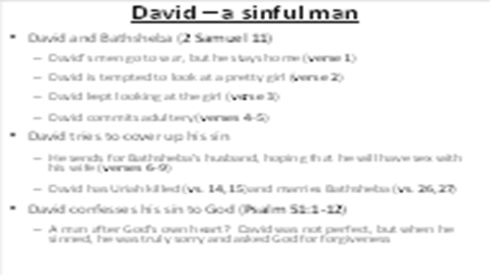 | But that doesn’t mean David was perfect. In fact, something you must know about the Bible: it give realistic pictures of all the “heroes.” They are all sinful and need God to save them. Turn to 2 Samuel 11. One time, while his army was out fighting, David stayed home (verse 1). He went out for an evening stroll and happened to see a beautiful woman taking a bath (verse 2). It is not a sin to be tempted - temptation comes to everyone. But the next thing David did was the problem (verse 3): he followed up on the temptation, leading to adultery (verse 4) and pregnancy (verse 5).  In order to cover up his sin, he calls Bathsheba’s husband back from the battle, hoping he will have sex with her (verses 6-9). But Uriah’s integrity and loyalty shines forth, eventually leading David to arrange his death (verses 14,15). David then took Bathsheba as his wife (verses 26,27). But sin cannot be covered up, especially from God, and David’s family suffers death and division because of his sin.  You might be thinking, “How could a ‘man after God’s own heart’ commit such an evil sin?” Turn to Psalm 51. Notice the writing above the Psalm, showing when David wrote this song. Read verses 1 to 12 and listen to David’s prayer. You see that David was not a ‘man after God’s own heart’ because he was perfect, but because he was truly sorry for his sin and asked God for forgiveness and renewal.
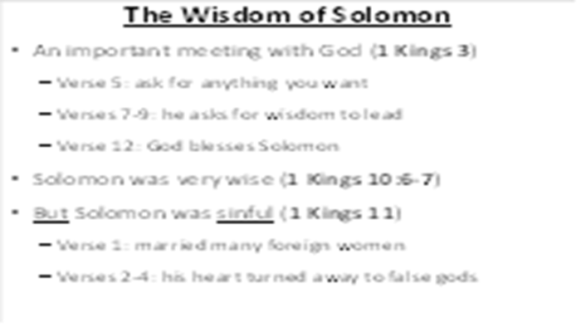 | After David died, one of his sons, Solomon, took his place as king over Israel. Solomon was a young man when he became king, and he had a very important meeting with God in 1 Kings 3:5. Solomon knew that he was young and weak, so he asked God for wisdom (verses 7-9), a request which pleased God (verses 10-15). God’s promise came true: Solomon was the wisest king of Israel, building a magnificent temple, counseling people from every nation, and writing several Bible books, including the book of Proverbs.  Although Solomon was very wise, he was not careful to follow his own wisdom. In the culture of those days, kings would often marry the daughters of other kings in order to seal a peace treaty. Even though Solomon knew that God had commanded against this (Deuteronomy 17:17), he followed the culture more than God. As we read in 1 Kings 11:1, we can see that Solomon married many women from foreign countries. And just as God had warned, his foreign wives pulled his heart away from God (verses 2-6). Please remember this: just learning about the Bible is not enough – we must do what it says.
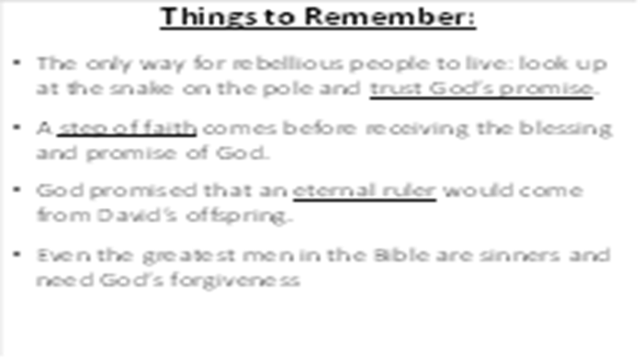 | There are many more things that we can learn from the Old Testament, but we need to move on to the New Testament. Tonight, I want you to remember some of the clues that we saw in these true stories:  * Because of their sin, people suffered death due to snakebites  * Snake bitten people could only live if they looked up at the snake on the pole and believed God  * A step of faith usually comes before receiving power from God  * God promised that an eternal ruler would come from David’s offspring.  * Even the greatest men in the Bible are sinners and need God’s forgiveness
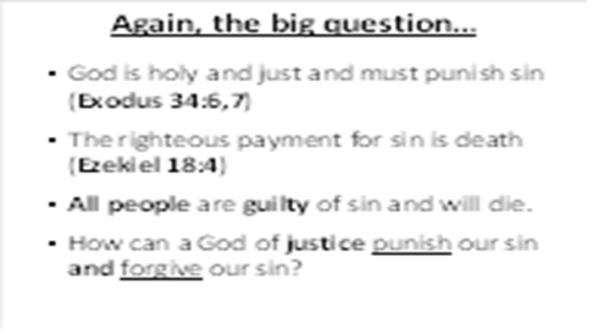 | As we close this lesson from the Old Testament, I hope that you have become aware of a very difficult problem:  A: God is perfectly holy and must punish sin, and  B: the righteous payment for sin is death, and  C: Every person is guilty of sin.  The equation is clear for all of us: A + B + C = death  So, is there any hope for anyone? How can a God of justice punish sin and forgive sin (Exodus 34:6,7)?
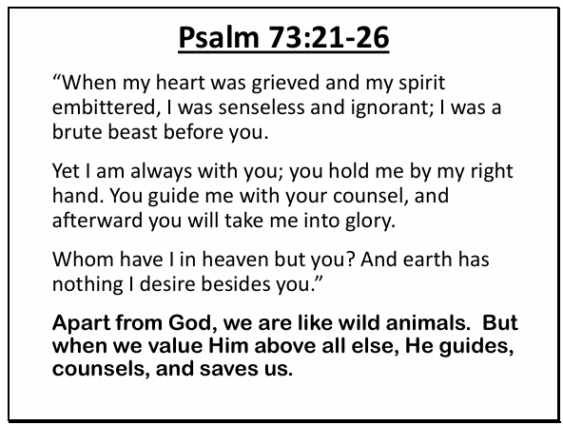 | In closing, I’d like for us to read a few verses from Psalm 73:21-26. When we are far away from God, we are like a brute beast. But then, He draws us near…

