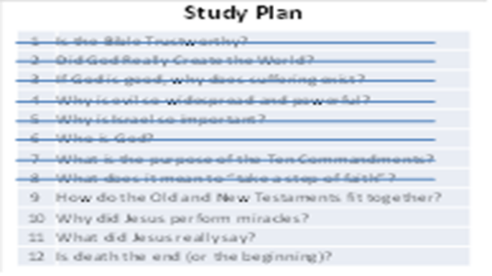
 | As I said at the beginning, the Bible is a very big book, therefore this brief study can only give a “high-level” overview. But even though we are looking at it from a very high level, I hope that you are able to see the central message of the Bible. After spending 2/3rds of our time looking at the Old Testament, today we will transition into the New Testament. But before we do, I need to remind you (again) of the two bug problems that we’ve learned about…
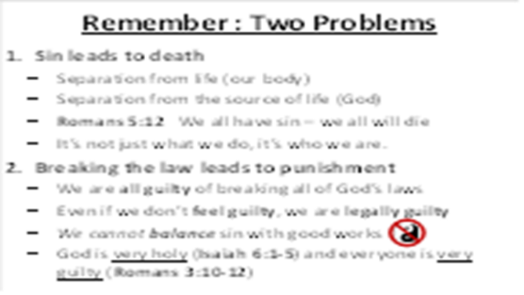 | Before we transition from the Old Testament to the New Testament, I want to go back and remind you of the two problems that face every person:  Sin leads to death (Genesis 2:16,17). Romans 5:12 reminds us that we inherited a sin nature from Adam. It’s not just what we do, it’s who we are. Because of sin, our life will be separated from our body. And even more importantly, we are separated from God.  Breaking the law leads to punishment (Exodus 20:1-20). We are all guilty of breaking all of God’s laws and should feel like David in Psalm 38:3,4, burdened by guilt and concerned about God’s pending judgment. Man-made religions teach us that we should balance our sin by doing good works. But when we get a clear understanding of the nature of God (Revelation 15:3,4,8) and the nature of man (Romans 3:19,20), it becomes clear that such a solution will never work (Proverbs 16:25).  These two problems represent the “bad news” in the Bible. Regardless of what people may want to believe, these problems will not go away if we ignore them and they cannot be overcome by human effort. Our only hope is this: God must do something to save us, something amazing and powerful. And in our brief study of the Old Testament, we have seen some clues that point us toward God’s ultimate solution for these terrible problems.
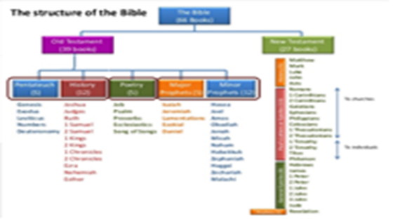 | In our study (so far), we’ve focused mainly on the first two sections of the Old Testament:  The Pentatuch – the first five books of history and the Law written down by Moses, often called the “Torah” by the Jews  History – true stories of the history of Israel and its kings  We’ve read some verses from the “Poetry” books of Psalms and Proverbs  Before we move into the New Testament, it is important that we look at a few important verses from the Prophets. Prophets were people who spoke words directly from God. Sometimes, those messages were specific instruction from God to His people to guide and correct their present behavior. They also spoke warnings about God’s coming judgment if the people continued to walk in sin. But sometimes, these messages from God were predictions of important events in the future. Let’s look at some of those next…
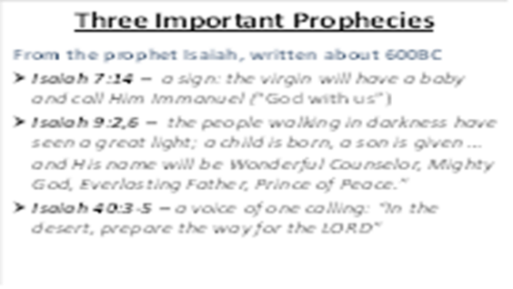 | First, here are three prophecies from the Isaiah, written down 600 years before Christ. The first two provide some important information about the birth of a very important child – the promised Savior. The third prophecy describes a person who will come first, preparing the way for the Savior.
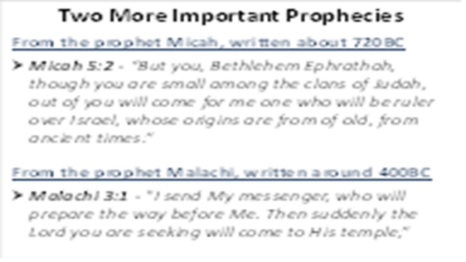 | Micah told the city where the Savior would be born. But He also gave an important fact about that Savior: His origins came before his physical birthdate – they are from ancient times.  Malachi was one of the last Old Testament Prophets, and he reminded the Jews that God’s promised Savior would come to save them. He also told them that before the Savior came, God would first send another prophet. This prophet would teach the people so that they would be ready for the coming Savior.  For 400 years after Malachi was written there was a period of silence. No words from God were given to the people of Israel. It might have felt like the 400 years of slavery in Egypt – people were probably wondering if God’s promised deliverer would ever come. But then …
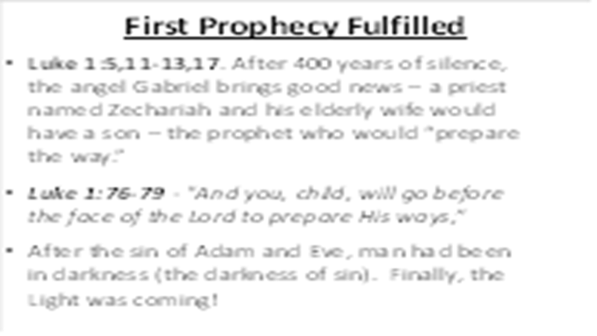 | … but then, something very important happened. During the reign of Herod the Great (ruler of Israel from 37-4BC), an angel appeared to a priest named Zechariah and gave him some great news (Luke 1:5,11-13,17). Zechariah and his elderly wife would have a son – this would be the prophet that Malachi said would “prepare the way.”  As we studied in the Old Testament, when God makes a promise, He will fulfill it. Sometimes a promise seems impossible to man, but nothing is too difficult for God. But, we know that God will fulfill every promise - down to every last detail. Zechariah’s wife Elizabeth gave birth to a son just like the angel said, and he was named John. His father then gave this prophecy:  Luke 1:76-79 Since the time of Adam and Eve, man had been in darkness (the darkness of sin). Finally, the time was coming!
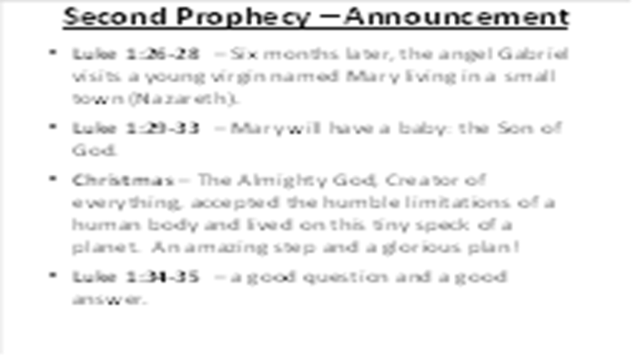 | Six months after the angel appeared to Zechariah, the angel came to have a talk with a young virgin named Mary living in a small town (Nazareth) Luke 1:26-33. The angel Gabriel told Mary that she would have a baby: the Son of God. She asked a very good question in v.34, and is given the clear answer in v.35 – God is able to do whatever He chooses.  Maybe you have heard this story before – the “Christmas” story. But please don’t miss the significance of this: The Almighty God, who created everything in the universe, awesome in power and glory, was about to take on the humble limitations of a human body and move onto this tiny speck of a planet. “Immanuel” – God with us, as a helpless baby. Can you imagine anything more amazing? For God to take such an unbelievable step, He must have had a glorious plan in mind.
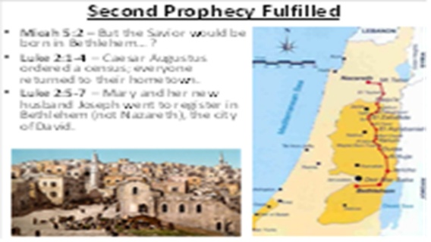 | Remember the prophecy concerning the birth of the Savior in Micah 5:2. It said that the Savior would be born in the city of Bethlehem. But we have a problem: Mary was from Nazareth. However, look what happens in Luke 2:1-4. Caesar Augustus (Caius Octavius) ruled the Roman Empire between 31BC and 14AD. About 8BC, he issued an order for a census (it probably took a few years to complete), requiring everyone to return to their hometowns. ( 户口 hùkǒu).  Because of this command, Mary and her new husband Joseph needed to register in Bethlehem, the city of David (his ancestor). In verses 5-7, we see that the child named Jesus was born in a humble stable, certainly not what you would expect for a normal king. But Jesus was not a normal king!
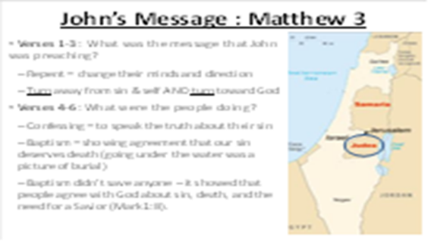 | There is much more to say about Jesus, but for now, let’s go back to the story of John, the one sent to announce the coming of the Savior and prepare the Jews to receive Him. God made sure that John gave an urgent and important message to get the people’s attention.  What was the message that John was preaching? When John used the word “repent” he meant that the people needed to turn from going their own way (away from God) and turn back to Him. They must admit that they had sinned against God by disobeying His laws and they couldn’t do anything to make themselves acceptable to Him. They must confess that all sin is against God and God hates sin and will always punish it by separating the sinner from Himself.  When a person was baptized, it was a sign to everyone else that the person agreed with God that he deserved death for his sins (going under the water was a picture of burial). It was also a sign that he believed that God would send a Savior to save him. Baptism doesn’t make God accept us and cannot pay the price that we deserve for our sins. The payment of sin is always death. Baptism is just a sign to show others that we agree with God’s message: we must repent of sin and place our complete trust in Him to save us.
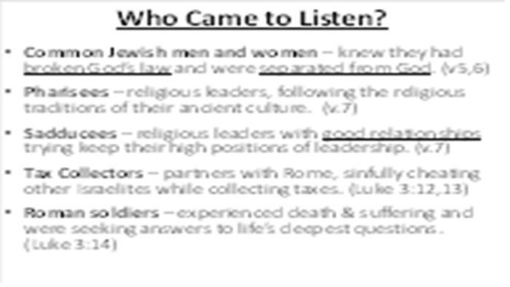 | At this time, there were many different kinds of people who came to John in the wilderness:  Normal Jewish men and women – people who knew that they had broken God’s law, were separated from God, and were seeking a solution for their problem.  Pharisees – proud religious leaders who tried to please God by their outward obedience to the law, following the traditions of their forefathers and maintaining the rituals of their ancient culture.  Sadducees – religious people who served in the temple but didn’t really believe many of the things God had said. Their goal was to maintain good relationships with the Roman government and keep their high positions of leadership.  Tax Collectors – Jewish men who worked for the Roman government to collect taxes from other Israelites. Since they often cheated their fellow citizens, they were deeply hated by everyone.  Roman soldiers – people who often experienced death and suffering and were seeking answers to life’s deepest questions.
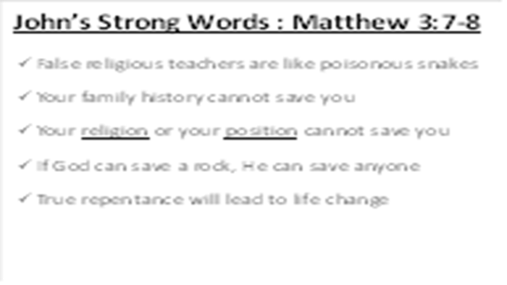 | Matthew 3:7-9 – John spoke some very strong words to the Jewish Leaders who came out to hear him. They assumed they were good enough to receive God’s favor and didn’t need to repent.  They thought that God would accept them just because they were descendants of Abraham. Some people think that they will be accepted by God because of their parent’s faith, because they try to be good, or because they went through some kind of ceremony. No one is accepted by God because of these things. God judges everyone individually - not by family, success, position, or religious activities. God will bless anyone that honestly admits their sin and will turn to Him.
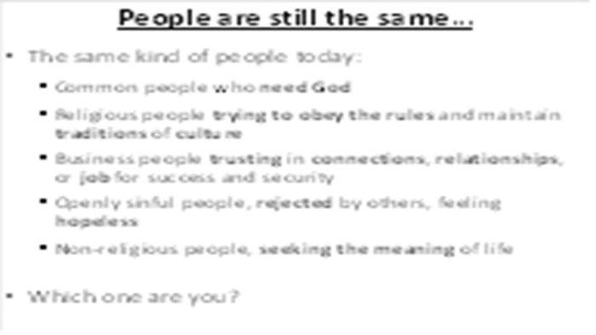 | As we close this lesson, remember: we have all offended God and are separated from Him – this is the “bad news” of the Bible. I wonder – which kind of person are you?  The common person who knows you have sinned and is seeking for God’s forgiveness?  The Roman solider who isn’t even sure if you believe in God, but want to understand the meaning of life?  The Pharisee who is trying to obey the rules and maintain traditions of culture?  The Sadducee, trusting in your connections, relationships, or job for success?  The Scribe, putting your hope in your education?
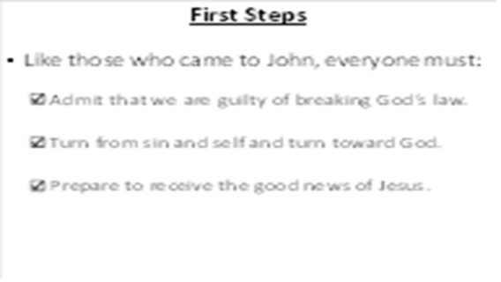 | Regardless of who you are, the first step we must take is to recognize that we are each guilty of breaking God’s law. Unless we take this first step of repentance and humility, we will not be appropriately prepared to receive the “good news” in the next lesson…

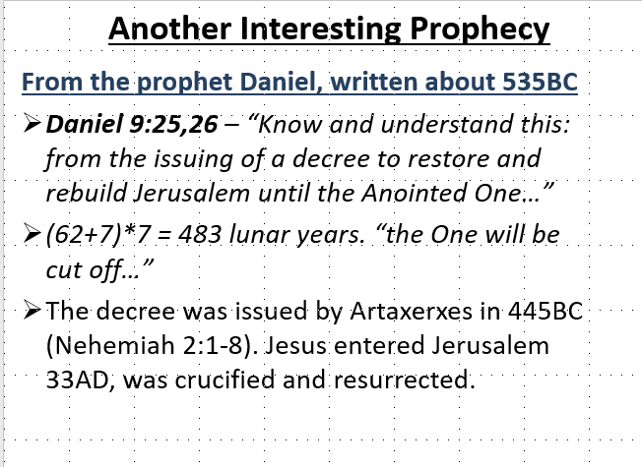 | Finally, here is an interesting prediction from the prophet Daniel around 535BC about the coming of “The … One”:  Daniel 9:25,26 – “Know and understand this: from the issuing of a decree to restore and rebuild Jerusalem until the Anointed One…” (62+7)*7 = 483 years. “the One will be cut off…” The decree was issued by Artaxerxes in 445BC (Nehemiah 2:1-8).

