
 | When God created the physical universe, He also created natural laws (of physics, chemistry, biology, etc) to keep things operating smoothly. Because these natural laws are generally predictable; they allow us to “do science.”  But when the Bible talks about “miracles,” it’s not just talking about an unusual and amazing event. A miracle is a “supernatural” event – something that overcomes natural law. When Jesus came to the earth, His ministry was characterized by miracles. Why?
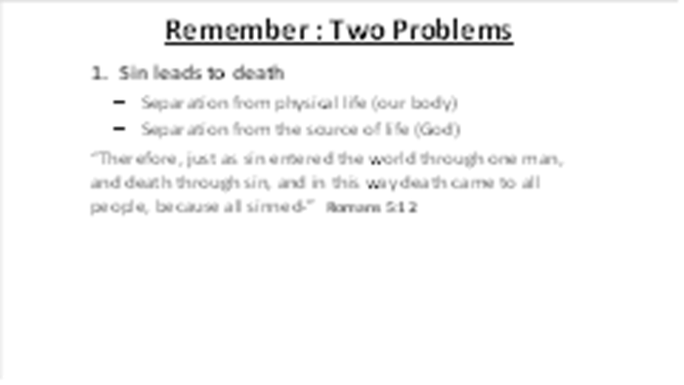 | As we make this transition from the Old Testament to the New Testament, I want to go back and remind you of the two problems that face every person:  Sin leads to death (Genesis 2:16,17). Romans 5:12 reminds us that we inherited a sin nature from Adam.
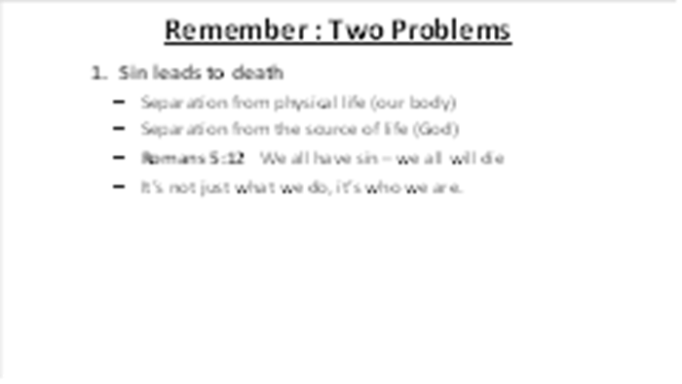 | Sin is not just what we do, it’s who we are. Because of sin, our life will be separated from our body. And even more importantly, we are separated from God.
 | Breaking the law leads to punishment (Exodus 20:1-20). We are all guilty of breaking all of God’s laws and even if we don’t feel guilty, we are legally guilty in the eyes of the Righteous Judge of every person in the world.  Man-made religions teach us that we should balance our sin by doing good works. But if we begin to understand the perfect righteousness of God (Isaiah 6:1-5), we understand that He will not accept some blending of good and evil.  When we fully grasp this, we should feel like David in Psalm 38:3,4, burdened by guilt and concerned about God’s pending judgment.
 | And when we see the true nature of man (Romans 3:10-12), it becomes clear that man-made solutions will never work (Proverbs 16:25).
 | These two problems represent the “bad news” in the Bible. Regardless of what people may want to believe, these problems will not go away if we ignore them and they cannot be overcome by human effort.  Our only hope is this: God must do something to save us, something amazing and powerful. And in our brief study of the Old Testament, we have seen some clues that point us toward God’s ultimate solution for these terrible problems.
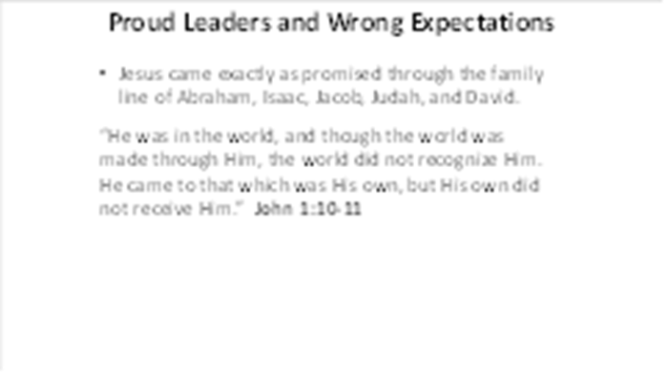 | After Jesus’ was born, He was raised as a by his mother Mary and her husband Joseph.  In the Jewish culture, a man had to be at least 30 years old before doing the work of God. So once Jesus turned 30 years old, He began His ministry. And as He began, He called 12 men to be His closest followers. They were not rich, powerful, leaders, scholars, or famous – just twelve ordinary men. We call these 12 men “apostles of Jesus.” The Greek word for apostle means a person who has been “sent out.” The apostles would soon be sent out by Jesus to bring the good news to the world.  Sadly, the Jewish leaders who should’ve been excited to receive Jesus were too busy with their religious traditions to see that He fit all of the prophecies of the promised Messiah. They rejected Jesus because of He did not follow their religious traditions and because they were jealous of His power and popularity.
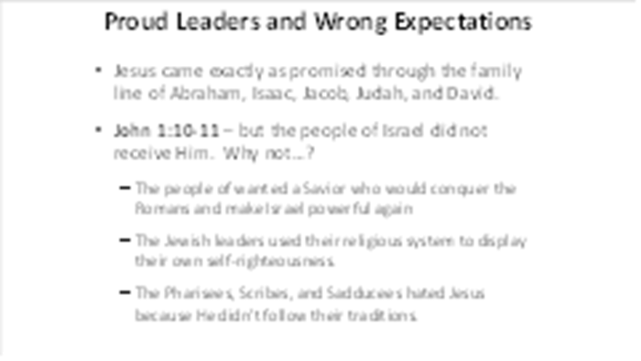 | But they were especially disappointed with Jesus because He did not do what they expected. They wanted a Messiah who would make Israel a great, glorious nation again. But Jesus had a much bigger objective than to temporarily rule a small middle-eastern country.
 | Jesus quickly became well known, drawing crowds wherever He went. As we read the true stories of Jesus’ works in the New Testament, we usually see three groups of people present: people who desire Jesus to meet their needs, teachers of the law who are jealous of Him and want to discredit Him, and a group in the middle that aren’t really sure what to think. We see these three groups in Mark 2:1-5. This man’s friends go to great trouble to have Jesus heal their friend. But He does something different than they expect – He forgives the man’s sins.  The legal teachers are angered by the claim of Jesus, and in their anger, they speak something true (Mark 2:6,7). They were correct when they said that God is the only one who can forgive sins. Their problem was this: they didn’t really know who Jesus was. But in Mark 2:8-12, He demonstrates power and authority that no one had ever seen. Jesus did supernatural things to show that He was the Creator of the universe – the One who created natural law and can overrule it.  Note This: Jesus didn’t do miracles to impress people – He did them to prove His identity and the truthfullness of His teaching. Here are some more examples:
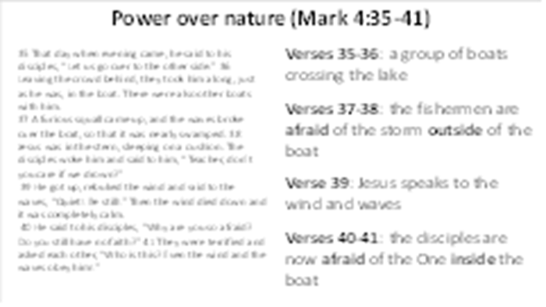 | Mark 4:35-41 – power over nature. This time, Jesus is in the boat with experienced fishermen. There were also other boats around (eyewitnesses). Some people falsely assume that the miracles of Jesus were only successful because of the power of positive thinking of people involved. But that idea obviously doesn’t fit when Jesus stops a storm and the waves.  Note This: At first, they are afraid of the terrible storm outside of the boat, but afterwards, they are terrified by the One inside of the boat, asking “Who is this?”
 | Mark 5:1-18 – power over demons. The spiritual powers of darkness inside of this man were too great for anyone to control (v.1-5). But in the presence of Jesus, he ran and confessed the truth about the greater power: “Jesus, Son of the Most High God” (v.6,7). Jesus commands the demons to depart, setting the man free and creating fear in the people (v.11-17). In the face of such power, some seek separation while one seeks to stay with Jesus (v.18).  This also demonstrates that demons are not all-knowing: although Jesus knew the pigs would rush down the hill and die, the demons couldn’t have predicted it.  Note This: Something important about this particular story: Jesus went all the way across the Sea of Galilee to save one demon-possessed man. This is an important reminder about the love of Jesus.
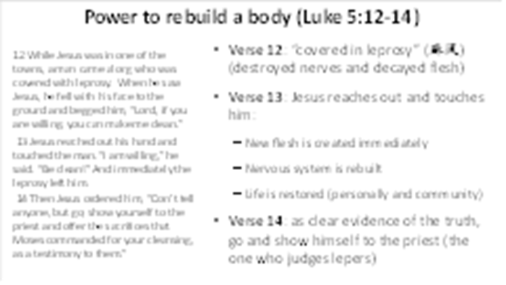 | Luke 5:12-14 – power to create new flesh. Leprosy was one of the most feared of all diseases, forcing people into isolation. When a man “covered in leprosy” (Hansen's disease) approaches Jesus, He does the unthinkable: “reached out His hand and touched the man,” instantly restoring his flesh, his nervous system, and his life.  Note This: The Old Testament laws indicated that if a person touched something (or someone) who was “unclean,” the uncleanness contaminated the person. But with Jesus, His cleanness flowed the other way, making the unclean man clean and righteous.
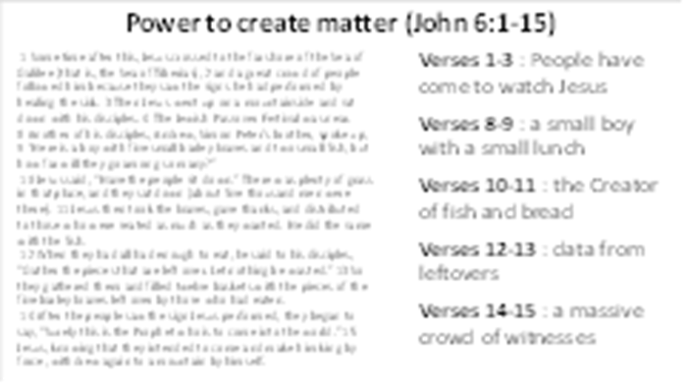 | John 6:1-4 - Power to create matter. In the beginning of this story, we see a great crowd of people coming to Jesus, amazed by His miraculous signs. As they get hungry, Jesus asks one of His disciples “where shall we buy bread” to feed these people? There wasn’t a noodle shop or KFC anywhere nearby, only a small boy with just a little food (vs. 8,9). So Jesus has the people sit down, He breaks the loaves and the fish, and in the sight of everyone present, He creates more bread and more fish (vs. 10,11). The people are amazed and decide to make Jesus their national king. But Jesus did not come to be the ruler of the small Jewish nation. He had a much larger purpose with a different mission.  Note This: This miracle is also interesting because it would be impossible to fake. Thousands of people experienced the power of Jesus with all of their senses – a huge amount of evidence that would easily convince a jury in a courtroom.
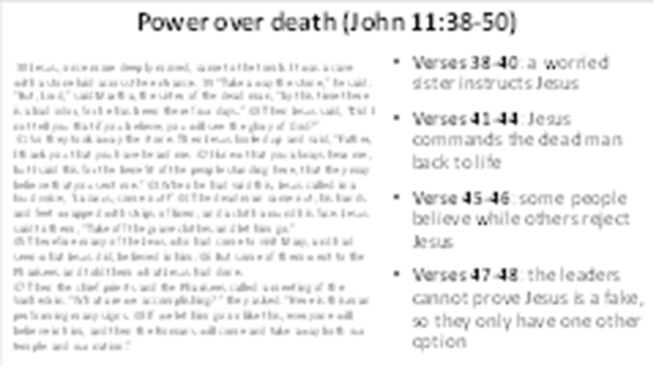 | (Remember to set this up by telling the back-story from the first part of John 11)  John 11:38-46 – power over death. Surrounded by supporters and skeptics, Jesus asks people to unseal the tomb of a dead man (v.38-42). At His call, the dead man comes out, wrapped in grave clothes (v.43-45). At such a clear display of His power, “many of the Jews … put their faith in Him.” But notice this: even though everyone was given the same evidence, some also chose to reject Jesus for fear of losing their position (v.46-48).  Note This: This story is a great example of something we often see in the Bible: two groups of people make opposite decisions, even though presented with the same convincing evidence. Don’t ever think that “a little more information” will help you to believe. Usually, a believing heart is needed to properly see the evidence.
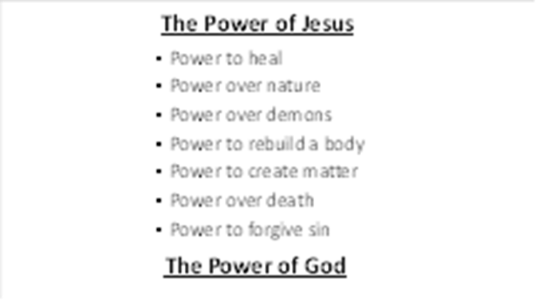 | We only looked at a sampling of the miracles of Jesus, but it should quickly become obvious that Jesus is not just a man – He is God in the flesh (Immanuel). Especially when we see that He has the power to forgive sin!
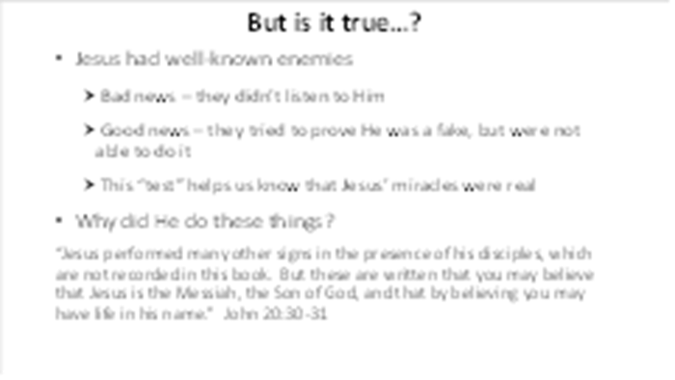 | Children and adults enjoy make-believe stories. These are interesting and fun to read, but when we talk about eternity, we need to have the truth, not make-believe. Something to remember about these stories: Jesus had very powerful enemies, people who tried very hard to discredit his mighty works. If Jesus was a fraud, they would have quickly found out and told the world. But as you read the Bible (and other writings of those days), you will never find words that prove His works to be fraudulent.  Why did He do these amazing things? To prove that the words He spoke were true.
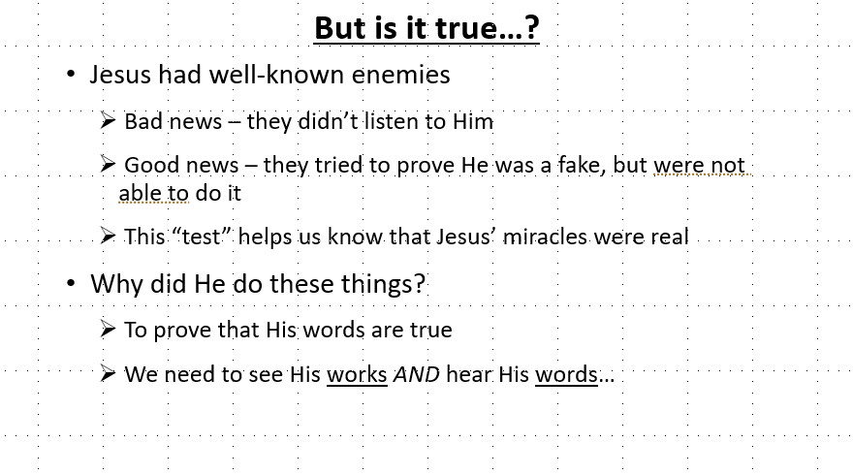 | It is not enough to just look at the powerful works of Jesus. We also need to listen to His words – why did He come and what message does He have for us.  What was His central message – His purpose for coming to this world?  That’s our next lesson…

